Prometheus and Grafana tasks

1. Install Prometheus on a server and configure prometheus.yml.

Objective
To install Prometheus on a Linux server, configure prometheus.yml, create a systemd service for Prometheus, and verify that Prometheus is running successfully in the background.
In this setup, Node Exporter is not used. Prometheus is configured to monitor itself on port 9090.

Prerequisites
Before starting the setup, ensure the following are available:
Linux/Ubuntu server
Root or sudo access
Internet connectivity
Prometheus package downloaded from the official website
Port 9090 available on the server
Basic knowledge of Linux commands and systemd
Official Prometheus download page:
https://prometheus.io/download/

Expected Outcome
After completing this activity:
Prometheus should be installed on the server.
prometheus.yml should be configured.
Prometheus should monitor its own server.
A systemd service should be created.
Prometheus should run as a background service.
Prometheus should automatically start after a server reboot.
Prometheus Web UI should be accessible on port 9090.
Prometheus target should show as UP.

Difficulties / Challenges
The following issues may occur during the setup:
Incorrect Prometheus directory path in the systemd service file.
Invalid syntax in prometheus.yml.
Prometheus service failing to start.
Port 9090 already being used by another process.
Firewall/Security Group blocking port 9090.
Prometheus not being enabled to start automatically after reboot.
These issues can be identified using promtool, systemctl, journalctl, and network troubleshooting commands.

Step-by-Step Procedure
Step 1: Download Prometheus
Go to the official Prometheus download page:
https://prometheus.io/download/
Download the appropriate Linux version.
For example:
cd /opt
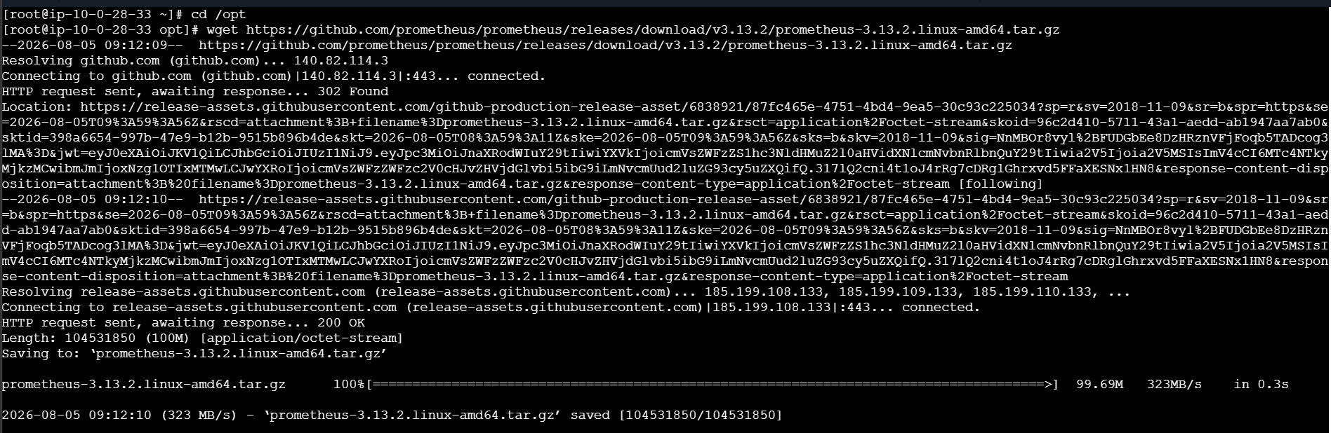
Extract the downloaded archive:
tar -xvf prometheus-<version>.linux-amd64.tar.gz
Move into the Prometheus directory:
cd prometheus-<version>.linux-amd64
Example:
cd /opt/prometheus-3.6.0-rc.0.linux-amd64

Step 2: Verify Prometheus Files
Run:
ls
The directory should contain files similar to:
prometheus
prometheus.yml
promtool
consoles
console_libraries

Step 3: Verify Prometheus Version
Run:
./prometheus --version
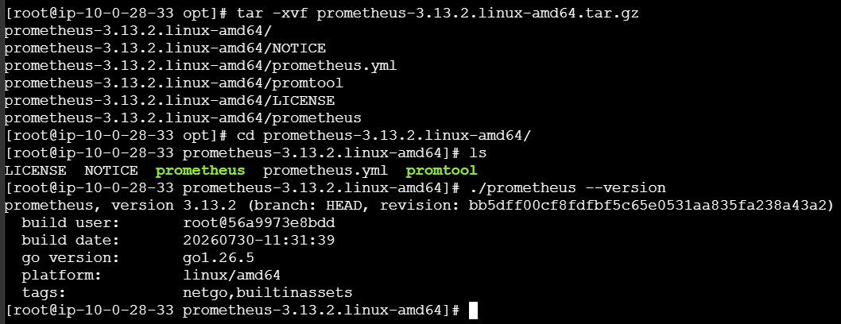
This verifies that the Prometheus binary is available and executable.

Configure prometheus.yml
Prometheus uses prometheus.yml as its main configuration file.
Open the file:
vi /opt/prometheus-<version>.linux-amd64/prometheus.yml
Use the following configuration:
global:
scrape_interval: 15s
evaluation_interval: 15s
scrape_configs:
- job_name: "prometheus"
static_configs:
- targets:
- "localhost:9090"
Configuration Explanation
scrape_interval
scrape_interval: 15s
Prometheus collects metrics every 15 seconds.
evaluation_interval
evaluation_interval: 15s
Prometheus evaluates rules every 15 seconds.
job_name
job_name: "prometheus"
Defines the name of the Prometheus monitoring job.
targets
targets:
- "localhost:9090"
This tells Prometheus to monitor its own Prometheus server.
Therefore, Node Exporter is not required for this setup.

Validate prometheus.yml
Before starting Prometheus, validate the configuration file.
Run:
./promtool check config prometheus.yml
Expected output:
Checking prometheus.yml
SUCCESS: prometheus.yml is valid prometheus config file syntax
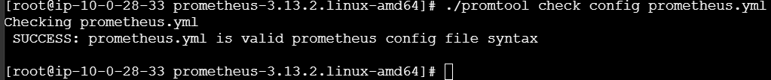
If the configuration is invalid, fix the YAML before starting Prometheus.

Test Prometheus Manually
Before creating the systemd service, test Prometheus manually.
Run:
./prometheus --config.file=prometheus.yml
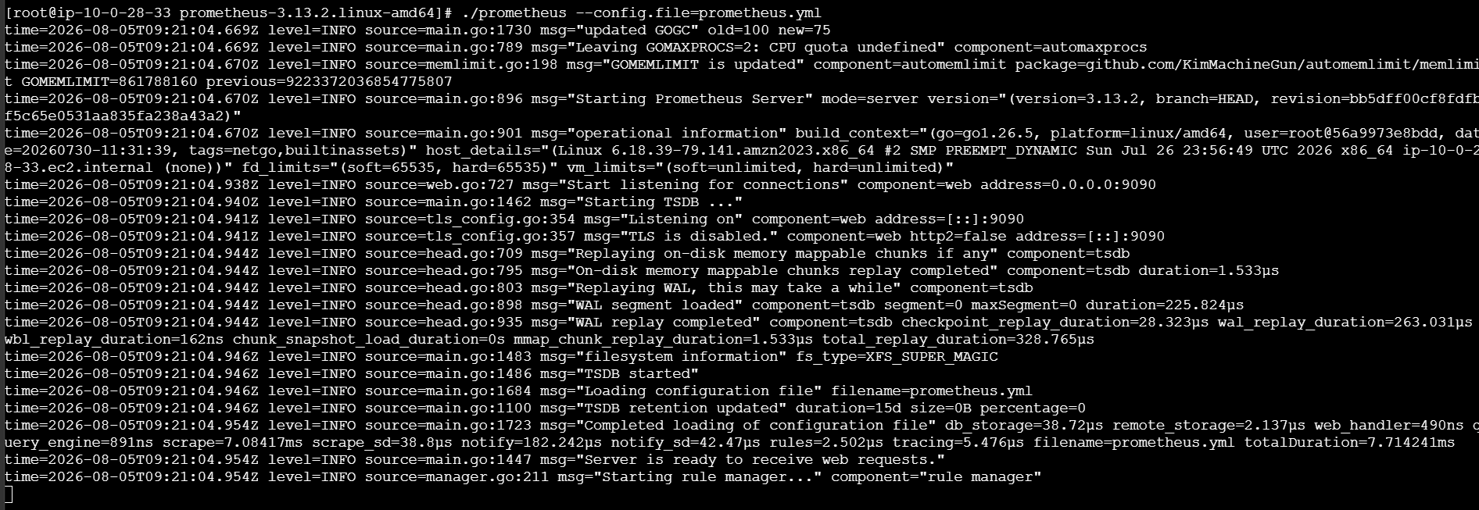
Prometheus should start successfully and listen on port 9090.
Access the Prometheus UI from a browser:
http://<SERVER-IP>:9090
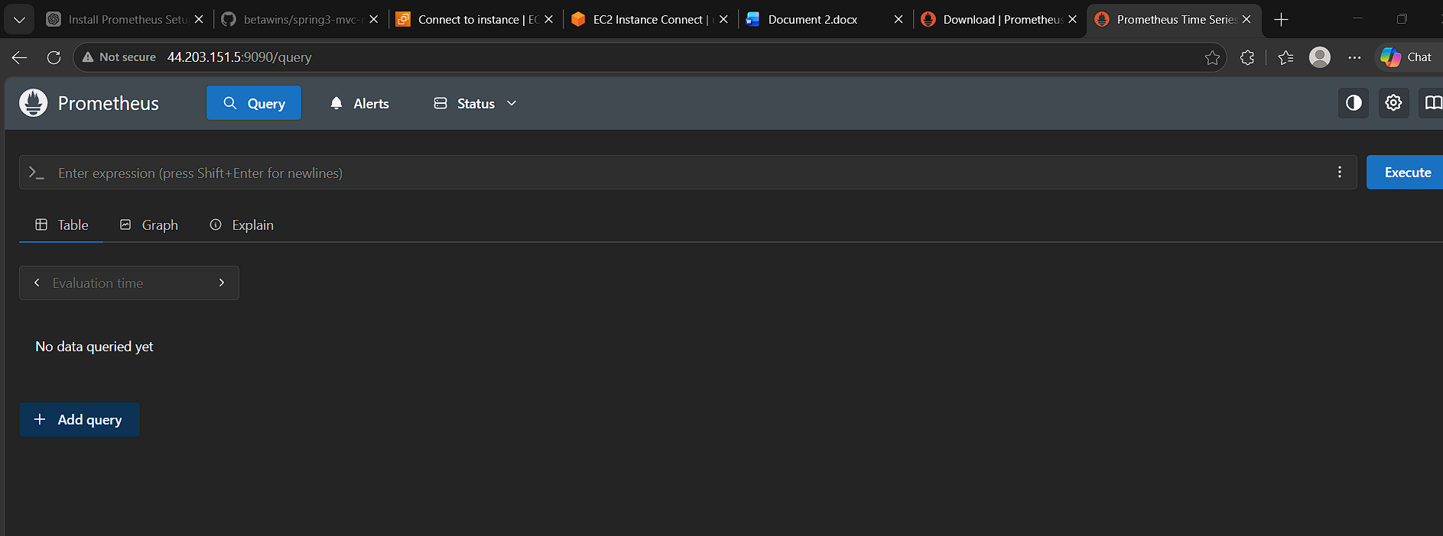
For example:
http://192.168.1.100:9090
Stop the manually running Prometheus process:
Ctrl + C

Create Prometheus systemd Service
To run Prometheus in the background and manage it using systemctl, create a service file.
Run:
sudo vi /etc/systemd/system/prometheus.service
Add:
[Unit]
Description=Prometheus Monitoring Service
Wants=network-online.target
After=network-online.target
[Service]
User=root
Group=root
Type=simple
ExecStart=/opt/prometheus-<version>.linux-amd64/prometheus \
--config.file=/opt/prometheus-<version>.linux-amd64/prometheus.yml \
--storage.tsdb.path=/opt/prometheus-<version>.linux-amd64/data \
--web.listen-address=:9090
Restart=on-failure
[Install]
WantedBy=multi-user.target
Important
Replace:
<version>
with the actual Prometheus directory name.
For example:
ExecStart=/opt/prometheus-3.6.0-rc.0.linux-amd64/prometheus \
--config.file=/opt/prometheus-3.6.0-rc.0.linux-amd64/prometheus.yml \
--storage.tsdb.path=/opt/prometheus-3.6.0-rc.0.linux-amd64/data \
--web.listen-address=:9090
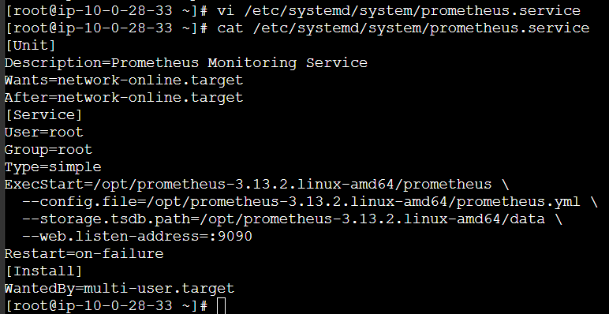

Reload systemd
After creating the service file, reload systemd:
sudo systemctl daemon-reload

Start Prometheus
Start the Prometheus service:
sudo systemctl start prometheus

Enable Prometheus
Enable Prometheus so that it automatically starts whenever the server is rebooted:
sudo systemctl enable prometheus

Check Prometheus Service Status
Run:
sudo systemctl status prometheus
Expected output should contain:
Active: active (running)
This confirms that Prometheus is running successfully as a background service.
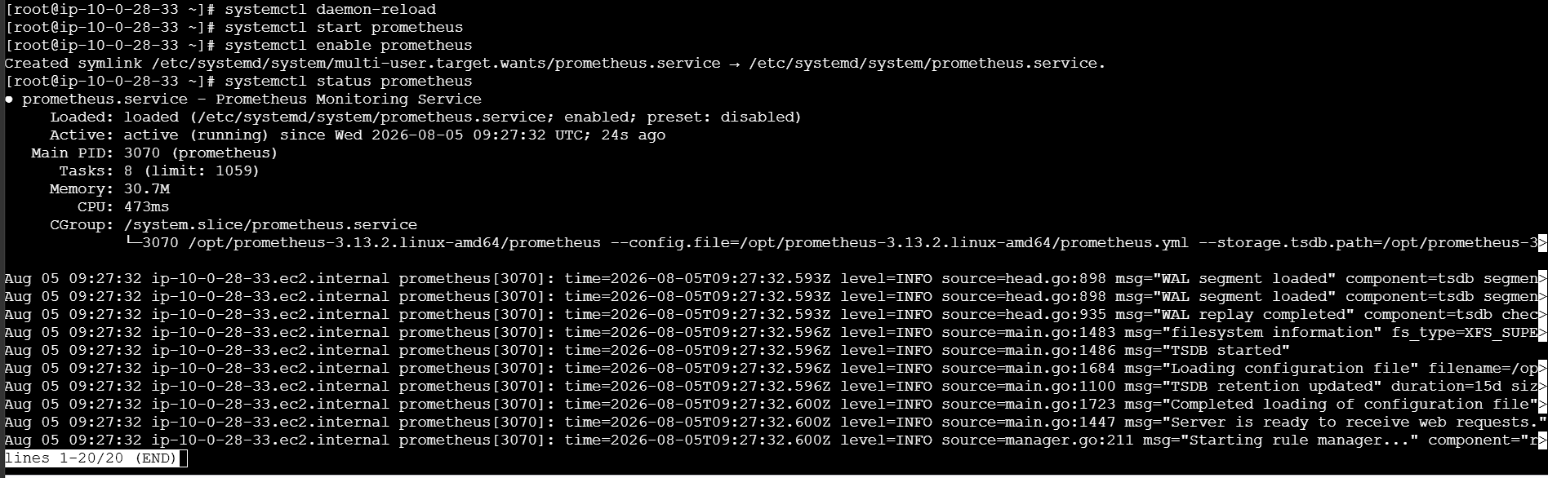
Check Prometheus Port
Prometheus uses port 9090 by default.
Run:
sudo ss -lntp | grep 9090
Expected output will be similar to:
LISTEN 0 4096 0.0.0.0:9090
This confirms that Prometheus is listening on port 9090.

Verify Prometheus Readiness
Run:
curl http://localhost:9090/-/ready
Expected:
Prometheus Server is Ready.
This confirms that Prometheus is ready to accept requests.

Access Prometheus Web UI
Find the server IP:
hostname -I
Open the following URL in a browser:
http://<SERVER-IP>:9090
Example:
http://192.168.1.100:9090
The Prometheus Web UI should open.
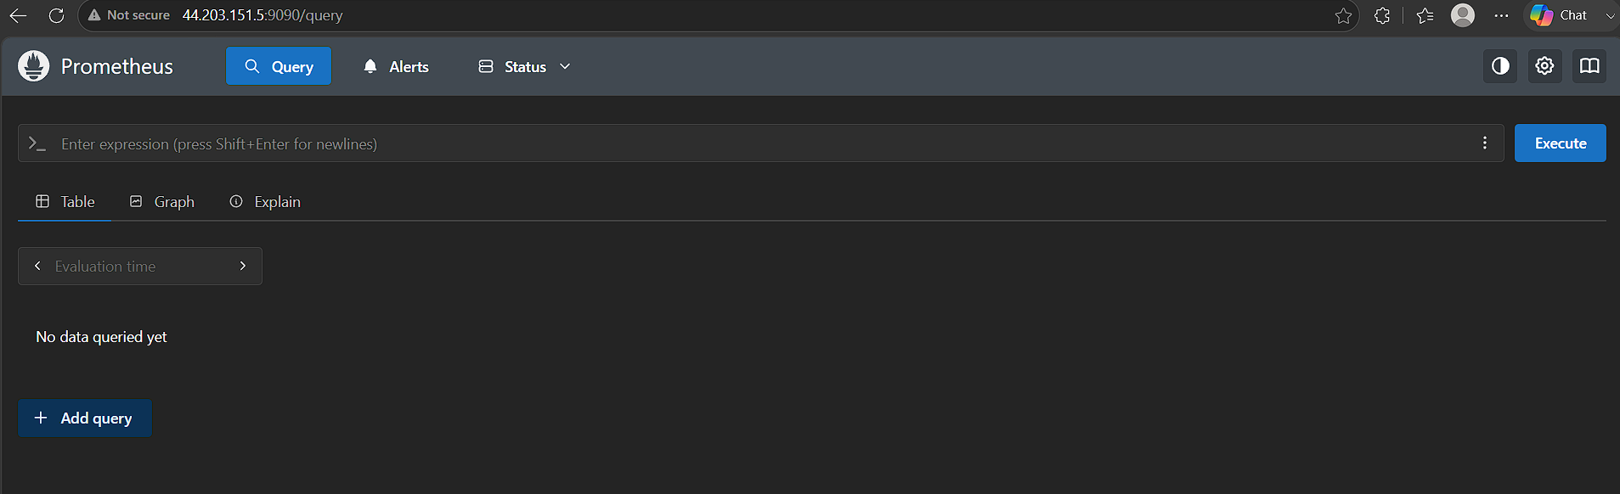
Verify Prometheus Target
In the Prometheus UI, navigate to:
Status → Targets
The following target should be displayed:
Job: prometheus
Endpoint: localhost:9090
State: UP
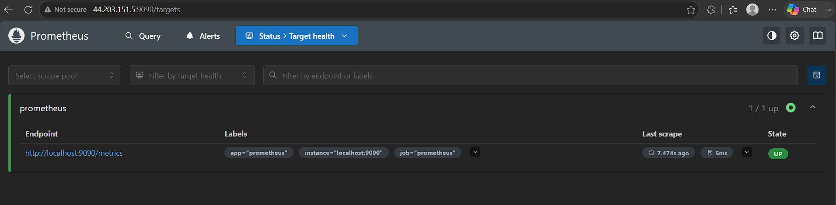
This confirms that Prometheus is successfully monitoring itself.

Test Prometheus Query
Open the Prometheus Web UI and execute the following query:
up
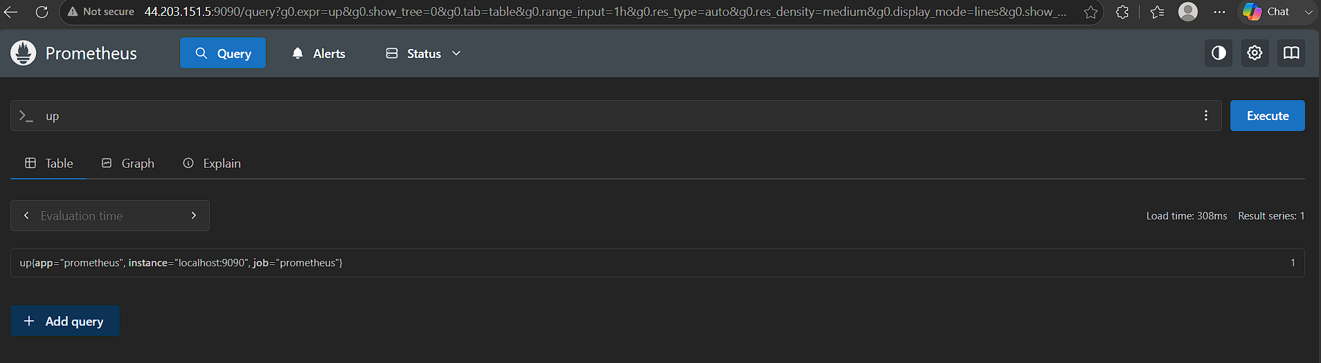
Expected result:
up{instance="localhost:9090",job="prometheus"} 1
The value:
1
indicates that the Prometheus target is UP.

Useful Troubleshooting Commands
Check service status
sudo systemctl status prometheus
View Prometheus logs
sudo journalctl -u prometheus -f
Check configuration
./promtool check config prometheus.yml
Check port 9090
sudo ss -lntp | grep 9090
Check Prometheus process
ps -ef | grep prometheus
Restart Prometheus
sudo systemctl restart prometheus
Stop Prometheus
sudo systemctl stop prometheus
Enable Prometheus at boot
sudo systemctl enable prometheus

Complete Command Summary
cd /opt
tar -xvf prometheus-<version>.linux-amd64.tar.gz
cd prometheus-<version>.linux-amd64
./prometheus --version
vi prometheus.yml
./promtool check config prometheus.yml
./prometheus --config.file=prometheus.yml
# Stop manually running Prometheus
Ctrl + C
sudo vi /etc/systemd/system/prometheus.service
sudo systemctl daemon-reload
sudo systemctl start prometheus
sudo systemctl enable prometheus
sudo systemctl status prometheus
sudo ss -lntp | grep 9090
curl http://localhost:9090/-/ready

Actual Outcome
Prometheus was successfully installed and configured on the Linux server.
The prometheus.yml file was configured with a scrape job targeting:
localhost:9090
A systemd service was created at:
/etc/systemd/system/prometheus.service
Prometheus was successfully started and enabled:
sudo systemctl start prometheus
sudo systemctl enable prometheus
The service status showed:
Active: active (running)
Prometheus was accessible through:
http://<SERVER-IP>:9090
The Prometheus target was verified from:
Status → Targets
and the target status was:
UP
Therefore, Prometheus was successfully installed, configured, and running as a background systemd service without using Node Exporter.

2. Install and configure Node Exporter for system monitoring.
Objective
To install and configure Node Exporter on a Linux server to collect system-level metrics such as CPU, memory, disk, filesystem, and network statistics, and expose them for monitoring by Prometheus.
Prerequisites
Before starting, ensure the following are available:
Linux/Ubuntu server
Root or sudo access
Internet connectivity
Prometheus server already installed and running
Port 9100 available
Basic knowledge of Linux commands and systemd
Node Exporter exposes system metrics on:
http://<SERVER-IP>:9100/metrics

Expected Outcome
After completing this activity:
Node Exporter should be installed successfully.
Node Exporter should run as a systemd service.
Node Exporter should listen on port 9100.
System metrics should be available through the /metrics endpoint.
Prometheus should be configured to scrape Node Exporter.
Node Exporter target should appear as UP in Prometheus.

Difficulties / Challenges

The following issues may occur:
Incorrect Node Exporter version or download URL.
Incorrect binary path in the systemd service file.
Node Exporter service failing to start.
Port 9100 already being used.
Firewall/Security Group blocking port 9100.
Incorrect IP address configured in Prometheus.
Prometheus configuration syntax errors.
Node Exporter target showing as DOWN in Prometheus.

Step-by-Step Procedure
Step 1: Download Node Exporter
Go to the official Prometheus download page:
https://prometheus.io/download/
Download the Node Exporter package suitable for your Linux server.
For this setup, we are using:
node_exporter-1.9.1.linux-amd64
Download or copy the package to /opt.
Example:
cd /opt
Extract the downloaded archive:
sudo tar -xvf node_exporter-1.9.1.linux-amd64.tar.gz
Verify:
ls -l /opt
You should see:
/opt/node_exporter-1.9.1.linux-amd64
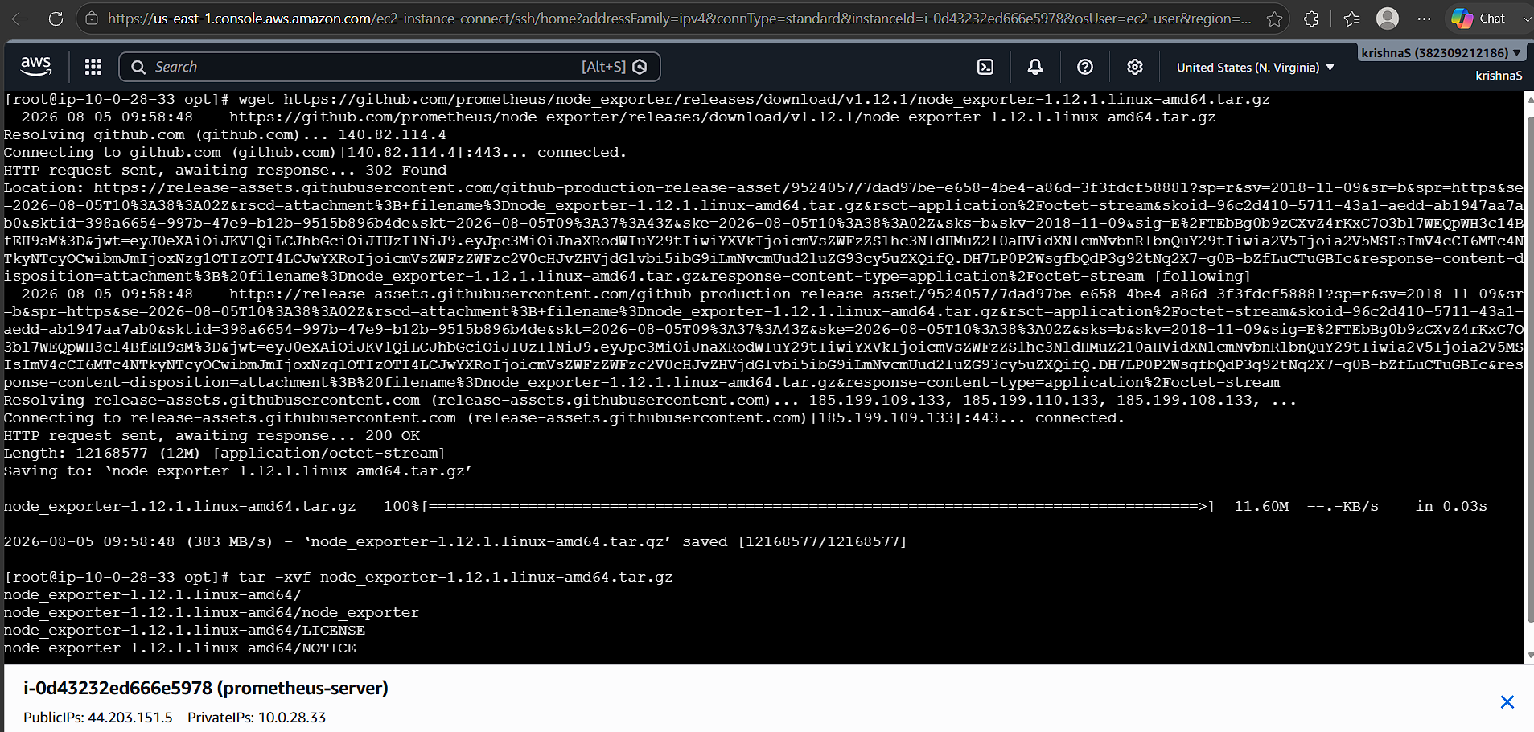
Step 2. Verify Node Exporter Binary
Move into the Node Exporter directory:
cd /opt/node_exporter-1.9.1.linux-amd64
Check the files:
ls
You should see:
node_exporter
LICENSE
NOTICE
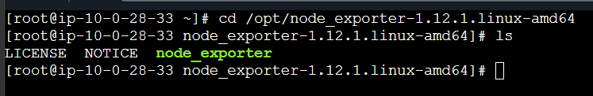
Verify the version:
./node_exporter --version
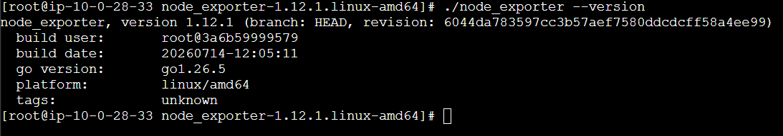
Step 3. Create Node Exporter Service
Create a systemd service file:
sudo vi /etc/systemd/system/node_exporter.service
Add the following:
[Unit]
Description=Node Exporter
After=network.target
[Service]
User=nobody
ExecStart=/opt/node_exporter-1.9.1.linux-amd64/node_exporter
Restart=on-failure
[Install]
WantedBy=multi-user.target
Note
The correct value is:
WantedBy=multi-user.target
not:
WantedBy=multi-user. Target
There should be no space between the . and target.
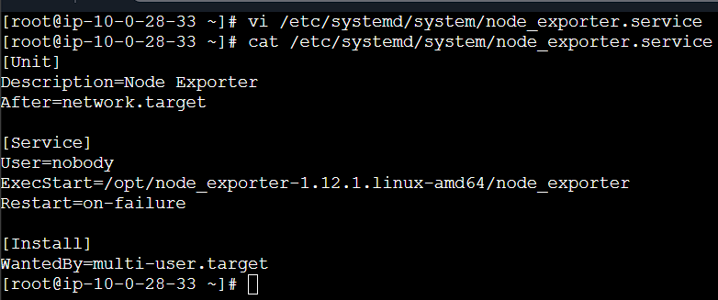
Step 4. Reload systemd
After creating the service file, reload the systemd configuration:
sudo systemctl daemon-reload

Step 5. Start Node Exporter
Start the Node Exporter service:
sudo systemctl start node_exporter
Check the service status:
sudo systemctl status node_exporter
Expected:
Active: active (running)
Step 6. Enable Node Exporter
Enable Node Exporter so that it starts automatically after server reboot:
sudo systemctl enable node_exporter
Verify:
sudo systemctl is-enabled node_exporter
Expected:
enabled
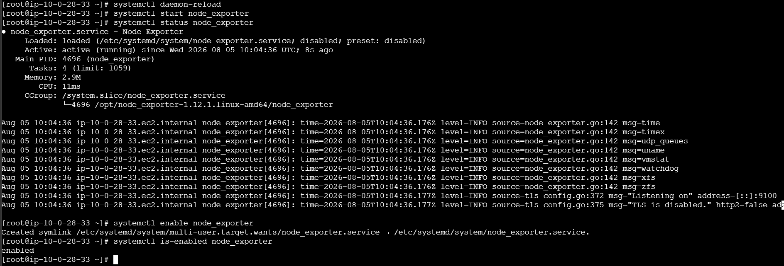
Step 7. Verify Node Exporter Port
Node Exporter uses port 9100 by default.
Run:
sudo ss -lntp | grep 9100
You should see Node Exporter listening on port 9100.
Step 8. Access Node Exporter Metrics
Node Exporter exposes system metrics through the /metrics endpoint.
From the server itself:
curl http://localhost:9100/metrics
You should see output similar to:
# HELP node_cpu_seconds_total Seconds the CPUs spent in each mode.
# TYPE node_cpu_seconds_total counter
node_cpu_seconds_total{cpu="0",mode="idle"} ...
# HELP node_memory_MemAvailable_bytes Memory information field MemAvailable_bytes.
# TYPE node_memory_MemAvailable_bytes gauge
node_memory_MemAvailable_bytes ...
This confirms that Node Exporter is successfully exposing system metrics.
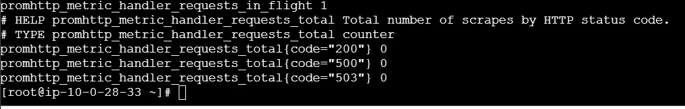
Step 9. Access Metrics from Browser
Node Exporter metrics can also be accessed from a browser.
Use:
http://<PUBLIC-IP>:9100/metrics
For example:
http://54.xx.xx.xx:9100/metrics
If this is an AWS EC2 server, ensure that the Security Group allows inbound TCP traffic on port 9100.
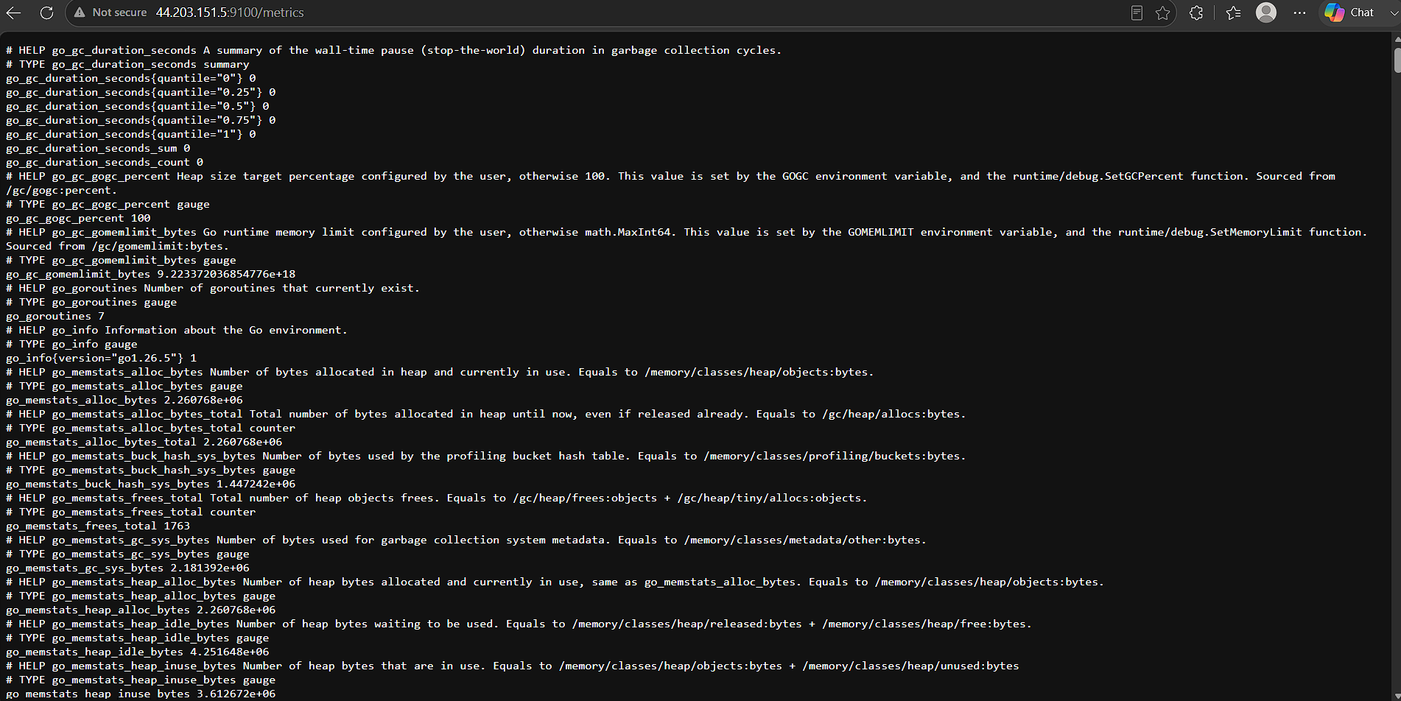
Step 10. Configure Node Exporter in prometheus.yml
Now add the Node Exporter target to the Prometheus configuration file.
Open the Prometheus configuration:
sudo vi /opt/prometheus-3.13.2.linux-amd64/prometheus.yml
Add the following under scrape_configs:
scrape_configs:
- job_name: 'node_exporter'
static_configs:
- targets: ['localhost:9100']
For example, the complete configuration could look like:
global:
scrape_interval: 15s
evaluation_interval: 15s
scrape_configs:
- job_name: 'prometheus'
static_configs:
- targets: ['localhost:9090']
- job_name: 'node_exporter'
static_configs:
- targets: ['localhost:9100']
Explanation
job_name: 'node_exporter'
Defines the monitoring job name.
targets: ['localhost:9100']
Tells Prometheus to collect metrics from Node Exporter running on port 9100.
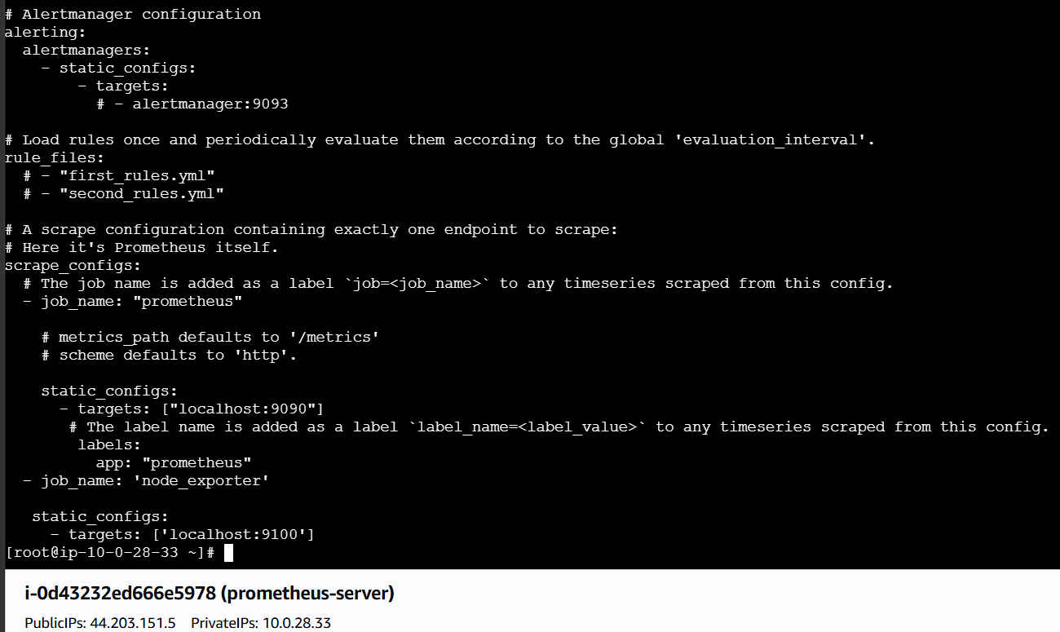
Step 11. Validate prometheus.yml
Before restarting Prometheus, validate the configuration.
Go to the Prometheus directory:
cd /opt/prometheus-3.12.1.linux-amd64
Run:
./promtool check config prometheus.yml
Expected output:
Checking prometheus.yml
SUCCESS: prometheus.yml is valid prometheus config file syntax
If there is an error, fix the YAML before restarting Prometheus.
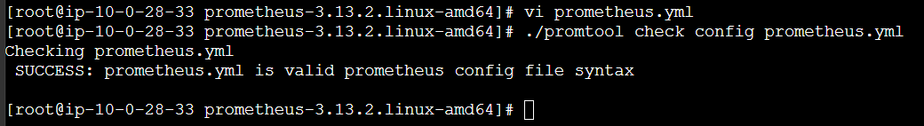
Step 12. Restart Prometheus
Restart Prometheus to load the new Node Exporter configuration:
sudo systemctl restart prometheus
Check the status:
sudo systemctl status prometheus
Expected:
Active: active (running)
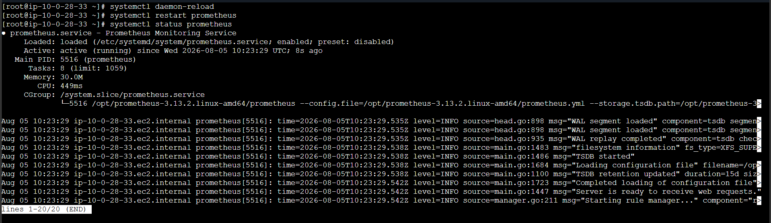
Step 13. Verify Node Exporter Target
Open the Prometheus dashboard:
http://<PROMETHEUS-SERVER-IP>:9090
Go to:
Status → Targets
You should see:
Job Endpoint State
node_exporter localhost:9100 UP
The target state should be:
UP
This confirms that Prometheus is successfully collecting metrics from Node Exporter.
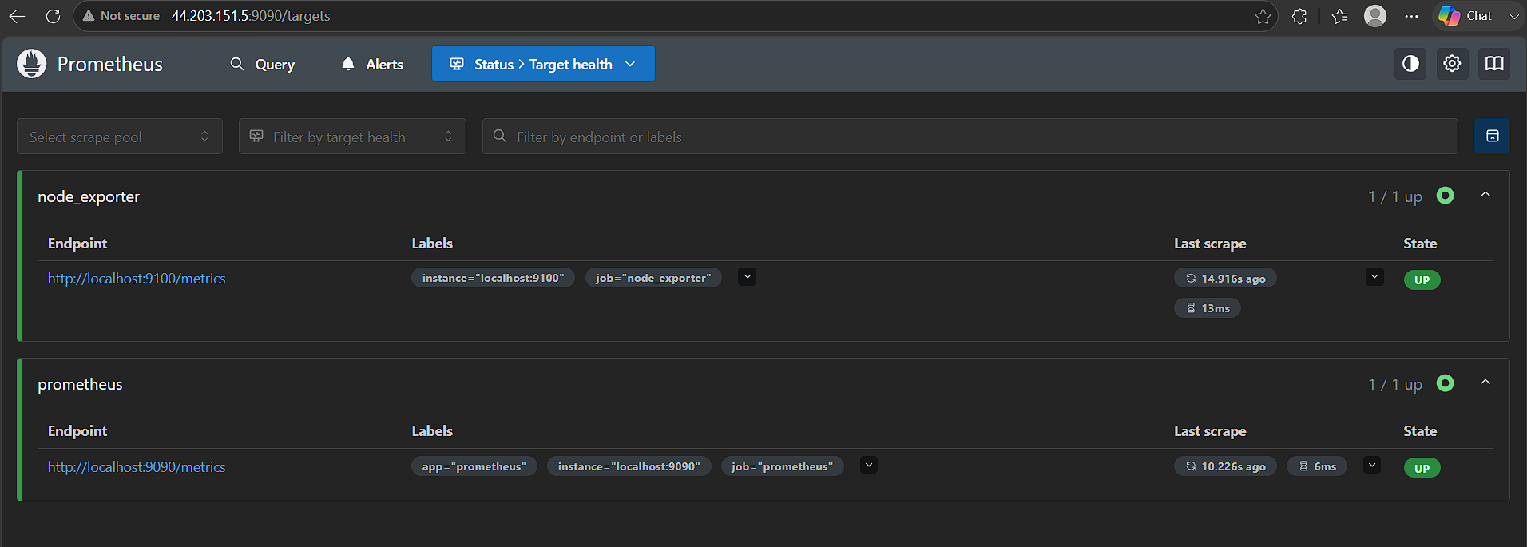
Step 14. Check CPU Metrics
Go to the Prometheus dashboard and search for:
node_cpu_seconds_total
You should see CPU-related metrics collected by Node Exporter.
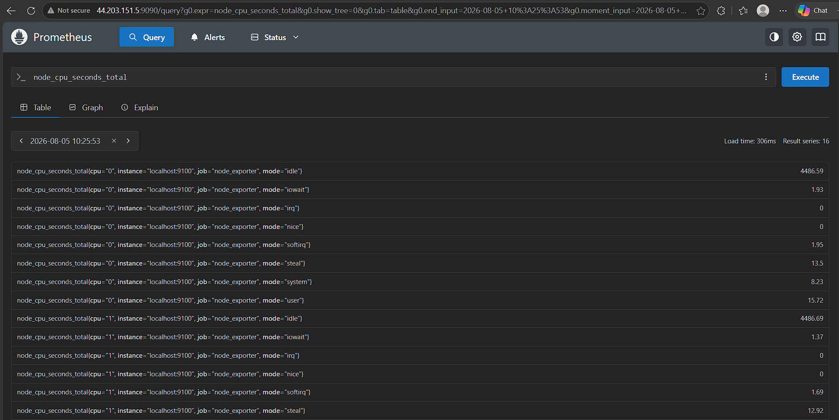
Step 15. Check Overall CPU Utilization
To check overall CPU utilization for the last one minute, use the following PromQL query:
100 - (avg by(instance)(irate(node_cpu_seconds_total{mode="idle"}[1m])) * 100)
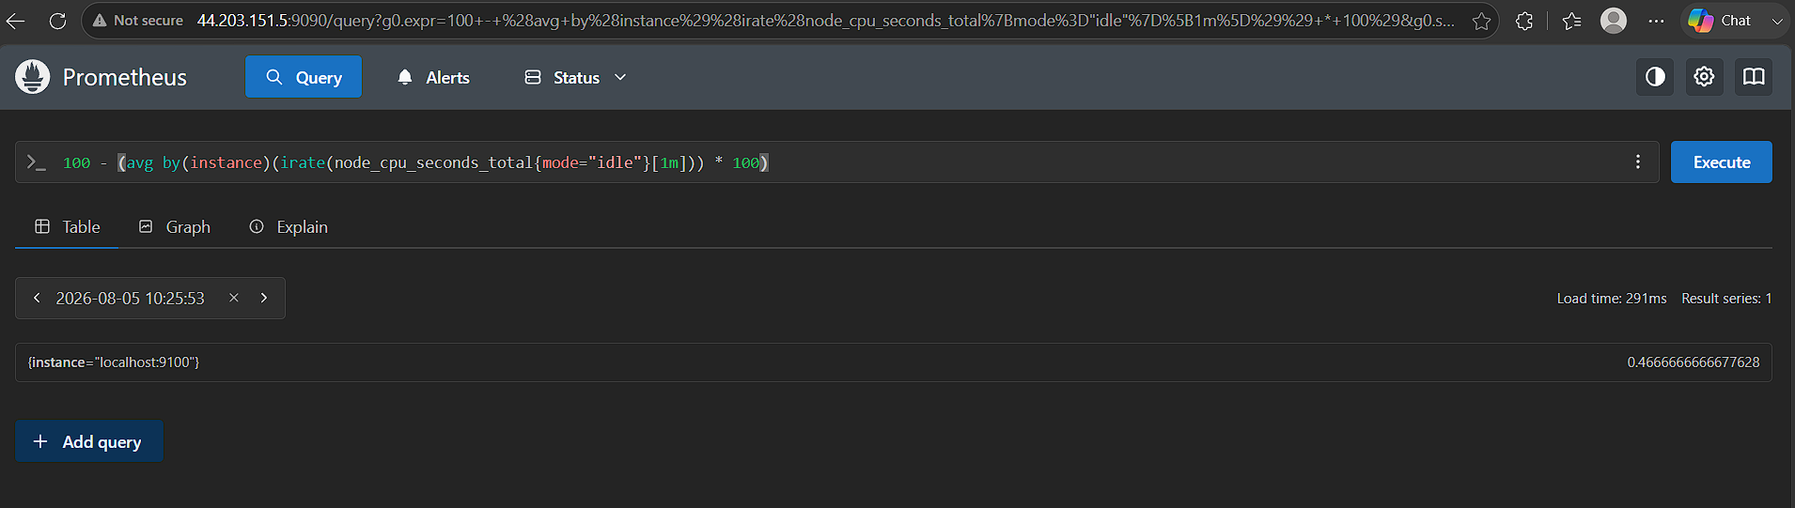Explanation
The query:
node_cpu_seconds_total{mode="idle"}
gets CPU idle time.
irate(...[1m])
calculates the per-second rate over the last one minute.
avg by(instance)(...)
calculates the average CPU idle percentage for each instance.
Finally:
100 - CPU Idle %
gives the approximate overall CPU utilization percentage.
For example:
CPU Idle = 35%
CPU Utilization = 100 - 35
CPU Utilization = 65%

Step 16. View CPU Metrics on Dashboard
After entering the query:
100 - (avg by(instance)(irate(node_cpu_seconds_total{mode="idle"}[1m])) * 100)
Click:
Execute
Then select:
Graph
The graph displays the CPU utilization of the monitored server over time.
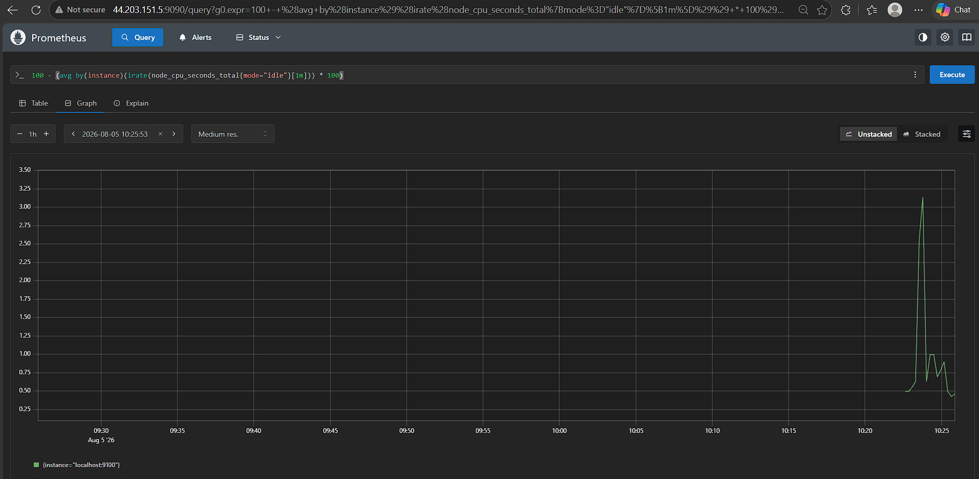
21. Troubleshooting
Check Node Exporter service
sudo systemctl status node_exporter
Check Node Exporter logs
sudo journalctl -u node_exporter -f
Check port 9100
sudo ss -lntp | grep 9100
Test Node Exporter manually
curl http://localhost:9100/metrics
Check Prometheus service
sudo systemctl status prometheus
Check Prometheus logs
sudo journalctl -u prometheus -f
Validate Prometheus configuration
./promtool check config prometheus.yml
Restart Node Exporter
sudo systemctl restart node_exporter
Restart Prometheus
sudo systemctl restart prometheus

22. Complete Command Summary
Node Exporter
cd /opt
sudo tar -xvf node_exporter-1.9.1.linux-amd64.tar.gz
cd node_exporter-1.9.1.linux-amd64
./node_exporter --version
sudo vi /etc/systemd/system/node_exporter.service
sudo systemctl daemon-reload
sudo systemctl start node_exporter
sudo systemctl enable node_exporter
sudo systemctl status node_exporter
sudo ss -lntp | grep 9100
curl http://localhost:9100/metrics
Prometheus Configuration
sudo vi /opt/prometheus-<version>.linux-amd64/prometheus.yml
Add:
- job_name: 'node_exporter'
static_configs:
- targets: ['localhost:9100']
Validate:
./promtool check config prometheus.yml
Restart:
sudo systemctl restart prometheus
Verify:
Prometheus → Status → Targets → node_exporter → UP

23. Actual Outcome
Node Exporter was successfully installed on the Linux server and configured as a systemd service.
The Node Exporter service was started using:
sudo systemctl start node_exporter
and enabled to start automatically after reboot using:
sudo systemctl enable node_exporter
Node Exporter was verified on port:
9100
The metrics endpoint was successfully accessed using:
http://<PUBLIC-IP>:9100/metrics
The following configuration was added to prometheus.yml:
scrape_configs:
- job_name: 'node_exporter'
static_configs:
- targets: ['localhost:9100']
Prometheus was restarted to apply the configuration.
The Node Exporter target was verified from:
Prometheus → Status → Targets
and the target status was:
UP
Finally, CPU utilization was monitored using:
100 - (avg by(instance)(irate(node_cpu_seconds_total{mode="idle"}[1m])) * 100)
The CPU utilization metrics were successfully displayed in the Prometheus dashboard.
Therefore, Node Exporter was successfully installed, integrated with Prometheus, and configured to monitor CPU utilization of the Linux server.

3. Set up SNMP Exporter to monitor network devices.

Objective
To install and configure SNMP Exporter and integrate it with Prometheus to monitor SNMP-enabled network devices such as routers and switches.

Prerequisites
Linux server with Prometheus installed
SNMP-enabled network device
Network device IP address
SNMP community string
Ports:
161/UDP – SNMP
9116/TCP – SNMP Exporter
9090/TCP – Prometheus

Expected Outcome
SNMP Exporter runs successfully on port 9116.
Prometheus collects SNMP metrics from the network device.
Network device appears as UP in Prometheus.

Procedure
Step 1: Install SNMP Utilities
sudo apt update
sudo yum install -y net-snmp net-snmp-utils

Test SNMP connectivity:
snmpwalk -v2c -c public 44.203.151.5

Step 2: Download SNMP Exporter
Download from: https://github.com/prometheus/snmp_exporter/releases/download/v0.30.1/snmp_exporter-0.30.1.linux-arm64.tar.gz

https://github.com/prometheus/snmp_exporter/releases
Extract:
cd /opt
tar -xvf snmp_exporter-0.30.1.linux-amd64.tar.gz
cd snmp_exporter-0.30.1.linux-amd64
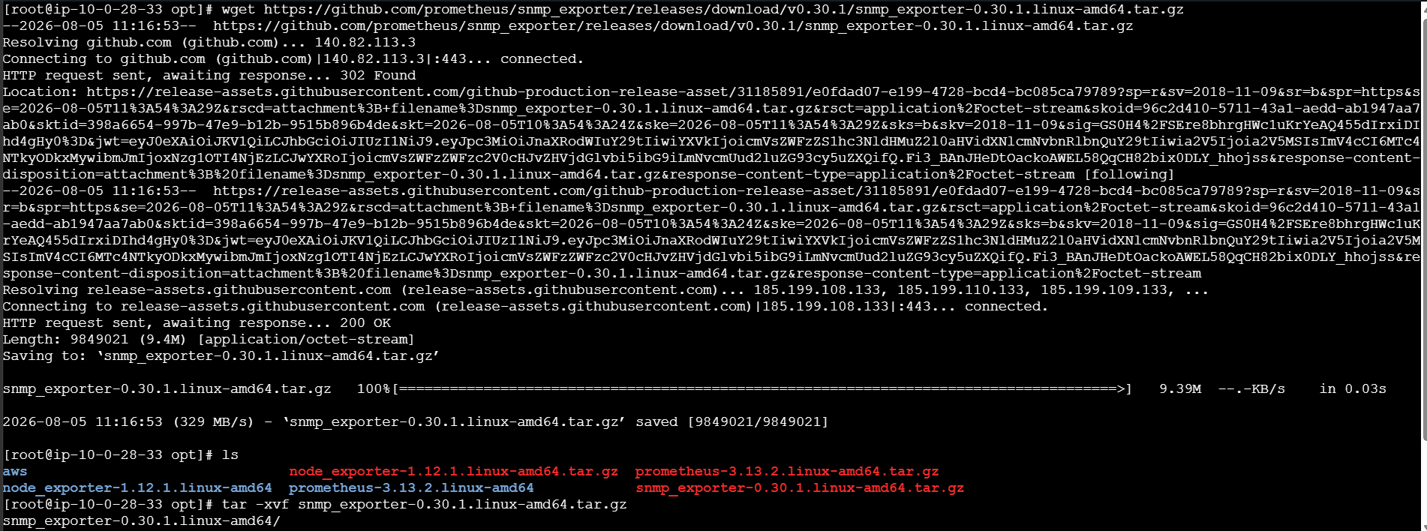

Step 3: Create SNMP Exporter Service
sudo vi /etc/systemd/system/snmp_exporter.service
Add:
[Unit]
Description=SNMP Exporter
After=network.target
[Service]
User=root
ExecStart=/opt/snmp_exporter-0.30.1.linux-amd64/snmp_exporter \
--config.file=/opt/snmp_exporter-0.30.1.linux-amd64/snmp.yml
Restart=on-failure
[Install]
WantedBy=multi-user.target

Start and enable:
sudo systemctl daemon-reload
sudo systemctl start snmp_exporter
sudo systemctl enable snmp_exporter
sudo systemctl status snmp_exporter
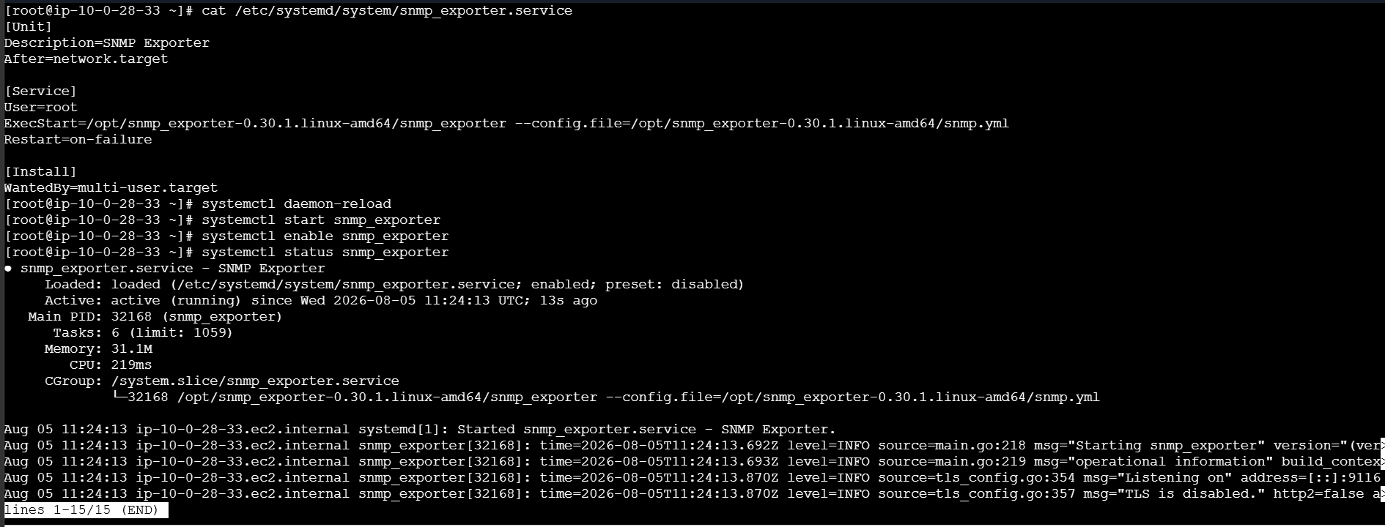
Step 4: Verify SNMP Exporter
SNMP Exporter runs on port 9116.
sudo ss -lntp | grep 9116
Test:
curl "http://localhost:9116/snmp?target=<NETWORK-DEVICE-IP>&module=if_mib"

Step 5: Configure Prometheus
Edit:
sudo vi /opt/prometheus-3.12.1.linux-amd64/prometheus.yml
Add:
scrape_configs:
- job_name: 'snmp'
static_configs:
- targets:
- 'localhost'
metrics_path: /snmp
params:
module: [if_mib]
relabel_configs:
- source_labels: [__address__]
target_label: __param_target
- source_labels: [__param_target]
target_label: instance
- target_label: __address__
replacement: 'localhost:9116'
Validate:
./promtool check config prometheus.yml
Restart Prometheus:
sudo systemctl restart prometheus

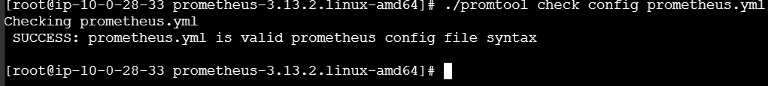

Step 6: Verify in Prometheus
Open:
http://<PROMETHEUS-IP>:9090
Go to:
Status → Targets
Verify:
snmp → UP
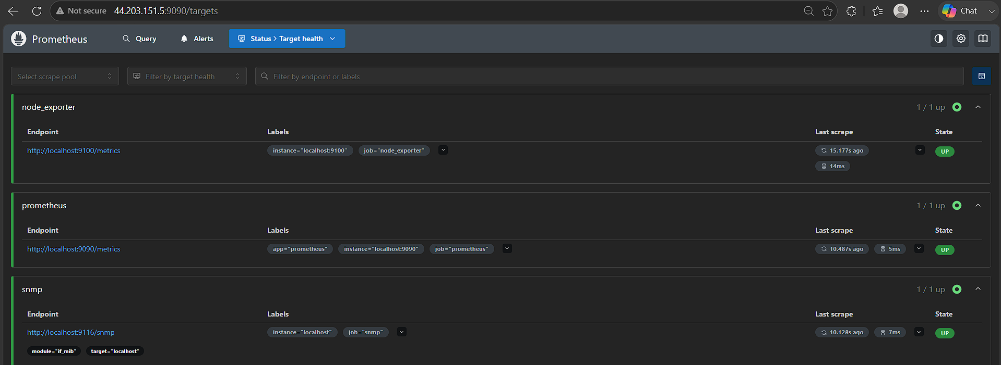
Test a network interface metric:
ifOperStatus
Check target status:
up{job="snmp"}
Expected:
1
Actual Outcome
SNMP Exporter was successfully installed and configured on the monitoring server. Prometheus was configured to scrape SNMP metrics from the network device, and the target was verified as UP in the Prometheus dashboard.

4. Set up Prometheus to run as a systemd service for automatic startup.
Objective
To configure Prometheus as a systemd service so that it runs in the background and automatically starts after server reboot.
Prerequisites
Linux server
Prometheus installed
Prometheus configuration file prometheus.yml
Prometheus binary available under /opt
Expected Outcome
Prometheus runs as a systemd service and automatically starts when the server boots.
Procedure
Step 1: Create Prometheus Service File
Create:
sudo vi /etc/systemd/system/prometheus.service
Add:
[Unit]
Description=Prometheus Monitoring Service
Wants=network-online.target
After=network-online.target
[Service]
User=root
Group=root
Type=simple
ExecStart=/opt/prometheus-3.13.2.linux-amd64/prometheus \
--config.file=/opt/prometheus-3.13.2.linux-amd64/prometheus.yml \
--storage.tsdb.path=/opt/prometheus-3.13.2.linux-amd64/data \
--web.listen-address=:9090
Restart=on-failure
[Install]
WantedBy=multi-user.target
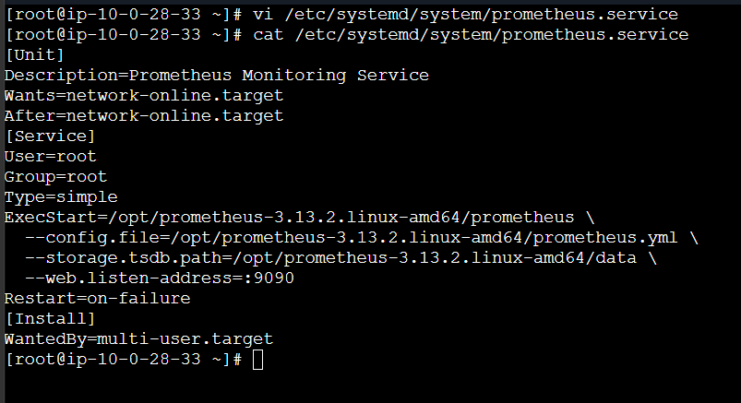
Step 2: Reload systemd
sudo systemctl daemon-reload
Step 3: Start Prometheus
sudo systemctl start prometheus
Step 4: Enable Automatic Startup
sudo systemctl enable prometheus
Step 5: Check Service Status
sudo systemctl status prometheus
Expected:
Active: active (running)
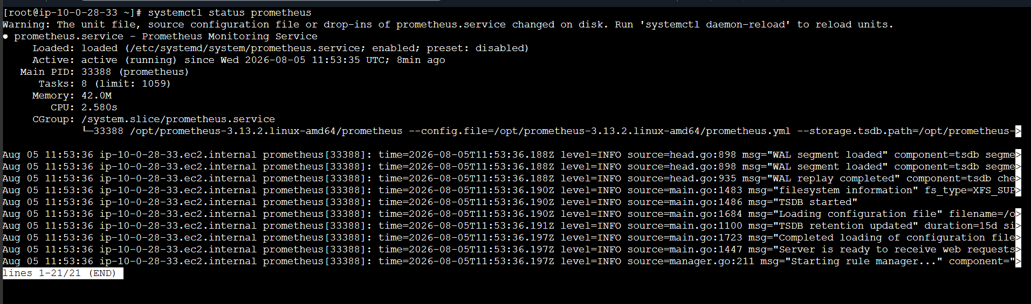
Step 6: Verify Prometheus
Open:
http://<SERVER-IP>:9090
Prometheus should be accessible through port 9090.
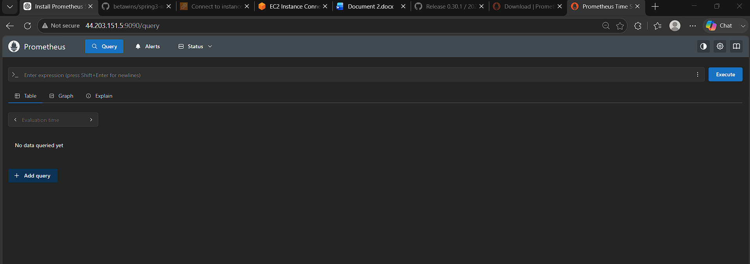
5. Actual Outcome
Prometheus was successfully configured as a systemd service, runs in the background, and is configured to start automatically after server reboot.

5. Install Alertmanager and configure an email alert.
Objective
To install Alertmanager, configure email notifications, and integrate it with Prometheus.
Prerequisites
Prometheus installed and running
Linux server
SMTP email account
Prometheus accessible on port 9090
Expected Outcome
Alertmanager receives alerts from Prometheus and sends email notifications when an alert is triggered.
Procedure
Step 1: Download Alertmanager
Download the latest Alertmanager from:
Prometheus Downloads
Extract it under /opt:
cd /opt
tar -xvf alertmanager-*.tar.gz
cd alertmanager-*/
Verify:
./alertmanager --version
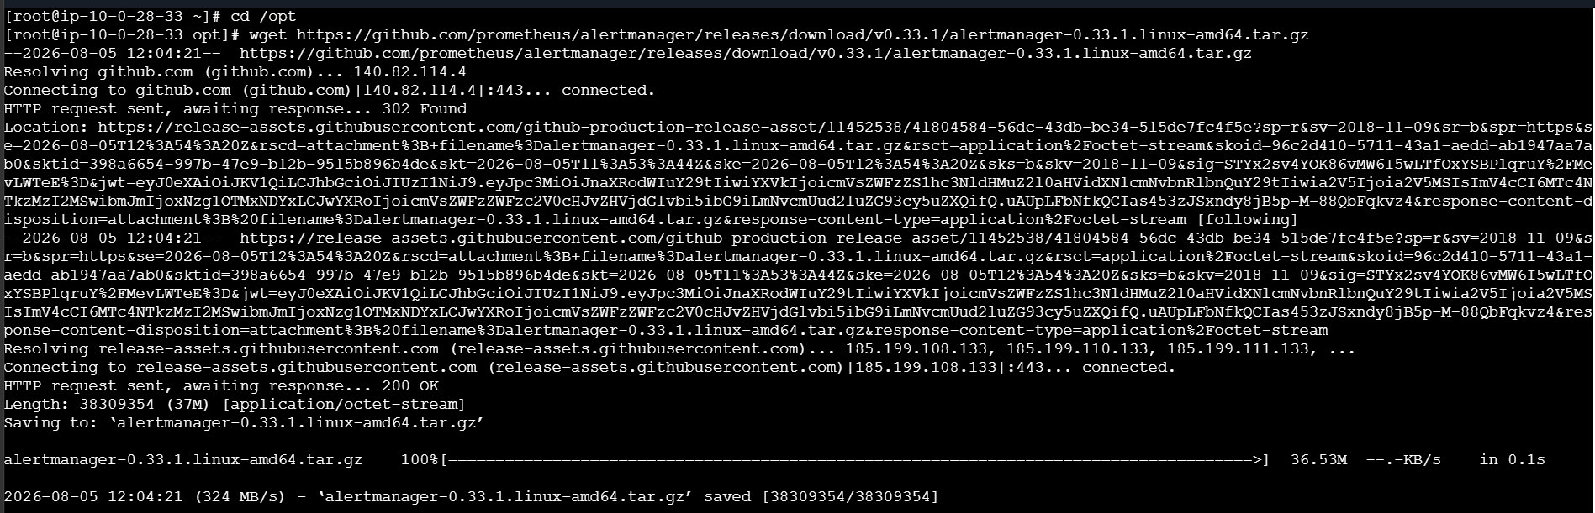
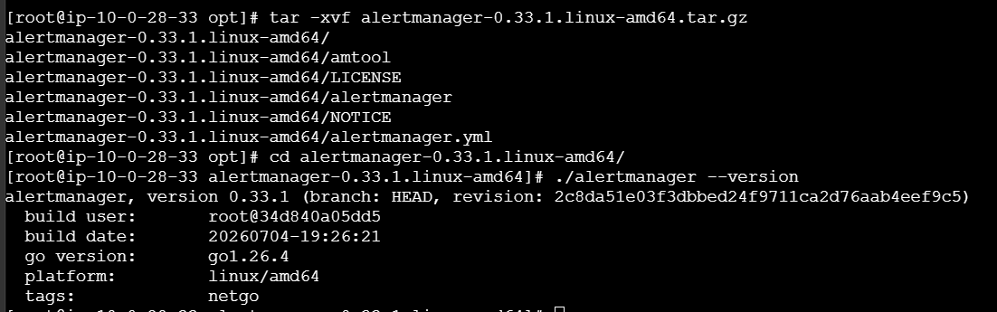
Step 2: Configure Alertmanager
Edit:
vi /opt/alertmanager-*/alertmanager.yml
Example SMTP configuration:
global:
smtp_smarthost: 'smtp.gmail.com:587'
smtp_from: 'your-email@gmail.com'
smtp_auth_username: 'your-email@gmail.com'
smtp_auth_password: 'YOUR_APP_PASSWORD'
route:
receiver: 'email-alert'
receivers:
- name: 'email-alert'
email_configs:
- to: 'your-email@gmail.com'
For Gmail, use an App Password instead of your normal Gmail password.
Step 3: Create Alertmanager Service
sudo vi /etc/systemd/system/alertmanager.service
Add:
[Unit]
Description=Alertmanager
Wants=network-online.target
After=network-online.target

[Service]
User=root
ExecStart=/opt/alertmanager-0.33.1.linux-amd64/alertmanager --config.file=/opt/alertmanager-0.33.1.linux-amd64/alertmanager.yml --storage.path=/opt/alertmanager-0.33.1.linux-amd64/data
Restart=on-failure

[Install]
WantedBy=multi-user.target
Note: Replace * with the actual Alertmanager directory name. Systemd does not expand * in ExecStart.
Step 4: Start Alertmanager
sudo systemctl daemon-reload
sudo systemctl start alertmanager
sudo systemctl enable alertmanager
Check:
sudo systemctl status alertmanager
Expected:
Active: active (running)
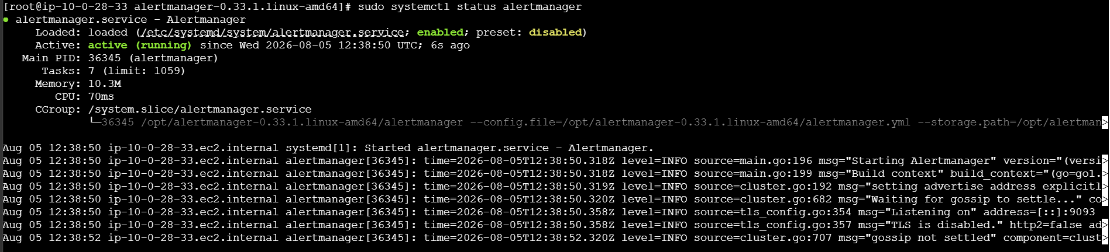
Alertmanager runs on:
http://<SERVER-IP>:9093
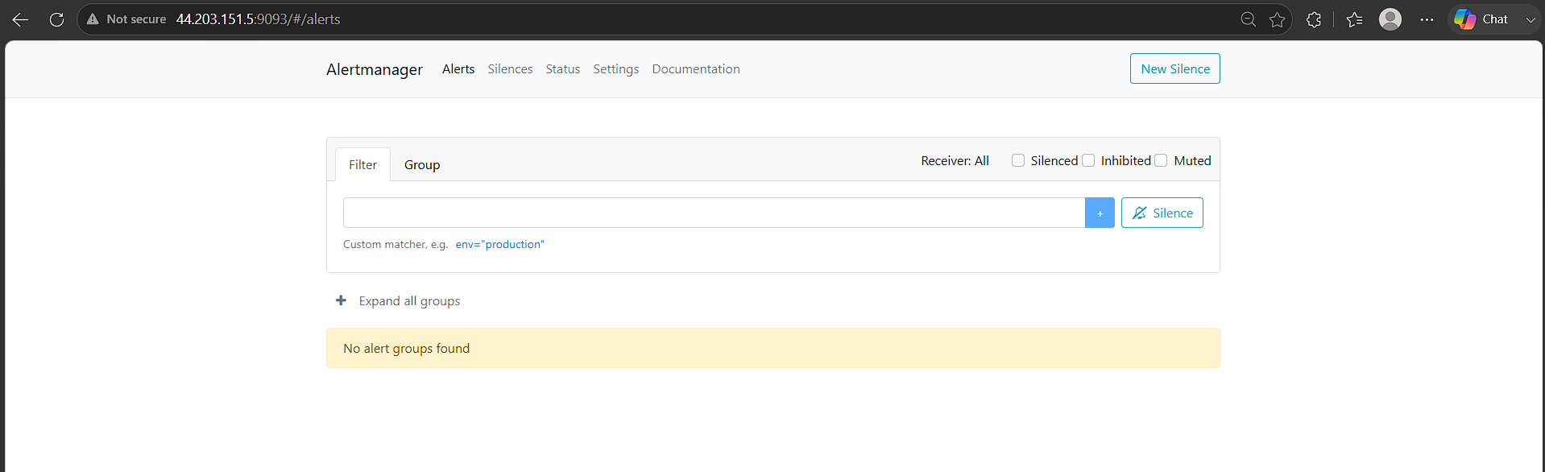
Step 5: Configure Prometheus
Edit:
vi /opt/prometheus-3.13.2.linux-amd64/prometheus.yml
Add:
alerting:
alertmanagers:
- static_configs:
- targets:
- "localhost:9093"
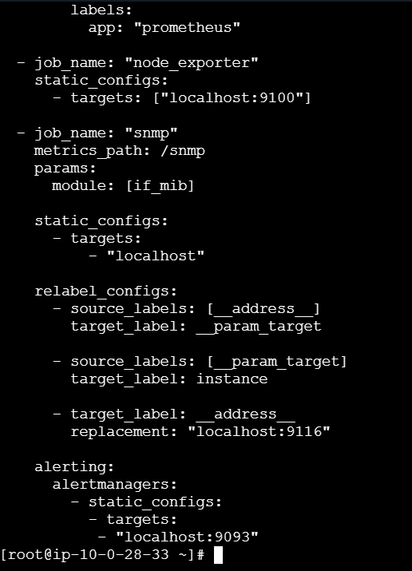
Step 6: Create an Alert Rule
Create:
vi /opt/prometheus-3.13.2.linux-amd64/alert.rules.yml
Add:
groups:
- name: server-alerts
rules:
- alert: PrometheusTargetDown
expr: up == 0
for: 1m
labels:
severity: critical
annotations:
summary: "Prometheus target is down"
description: "Target {{ $labels.instance }} has been down for more than 1 minute."
Add this to prometheus.yml:
rule_files:
- "alert.rules.yml"
Step 7: Validate and Restart Prometheus
cd /opt/prometheus-3.13.2.linux-amd64
./promtool check config prometheus.yml
./promtool check rules alert.rules.yml
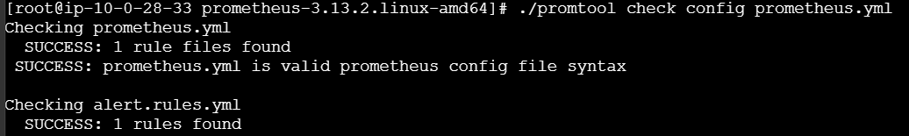
Then:
sudo systemctl restart prometheus
5. Verification
Check Prometheus:
http://<SERVER-IP>:9090/alerts
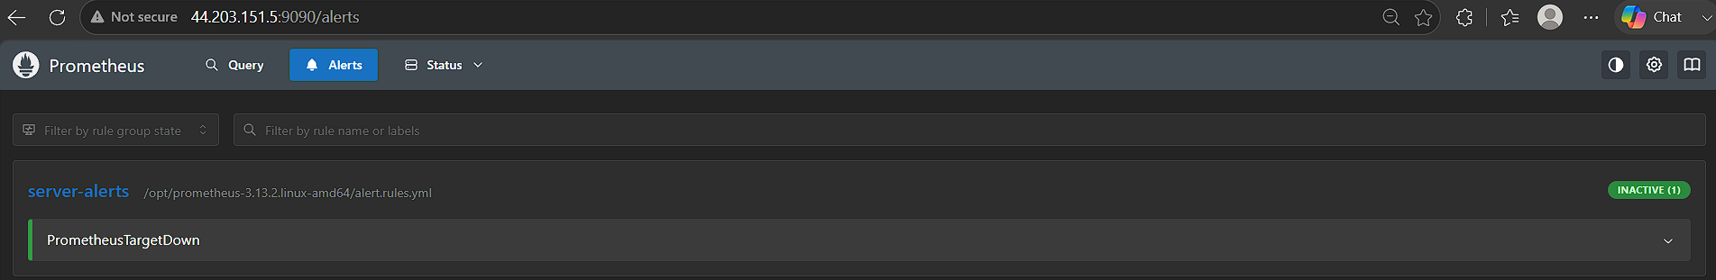
Check Alertmanager:
http://<SERVER-IP>:9093
When the alert condition is triggered, Prometheus sends the alert to Alertmanager, and Alertmanager sends an email notification.
Stop the node_exporter to trigger alerts
sudo systemctl stop node_exporter
As per the alert rules mentioned in alert-rules.yml file you need to wait 1 min to fire the alerts
No go check both the prometheus and alertmanager sites
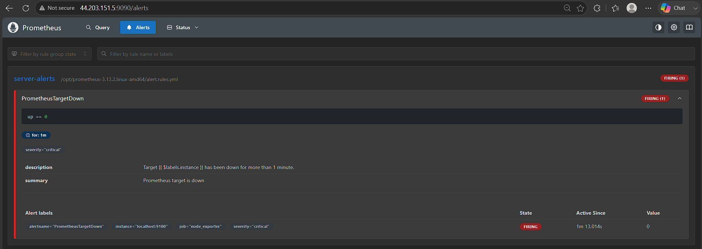
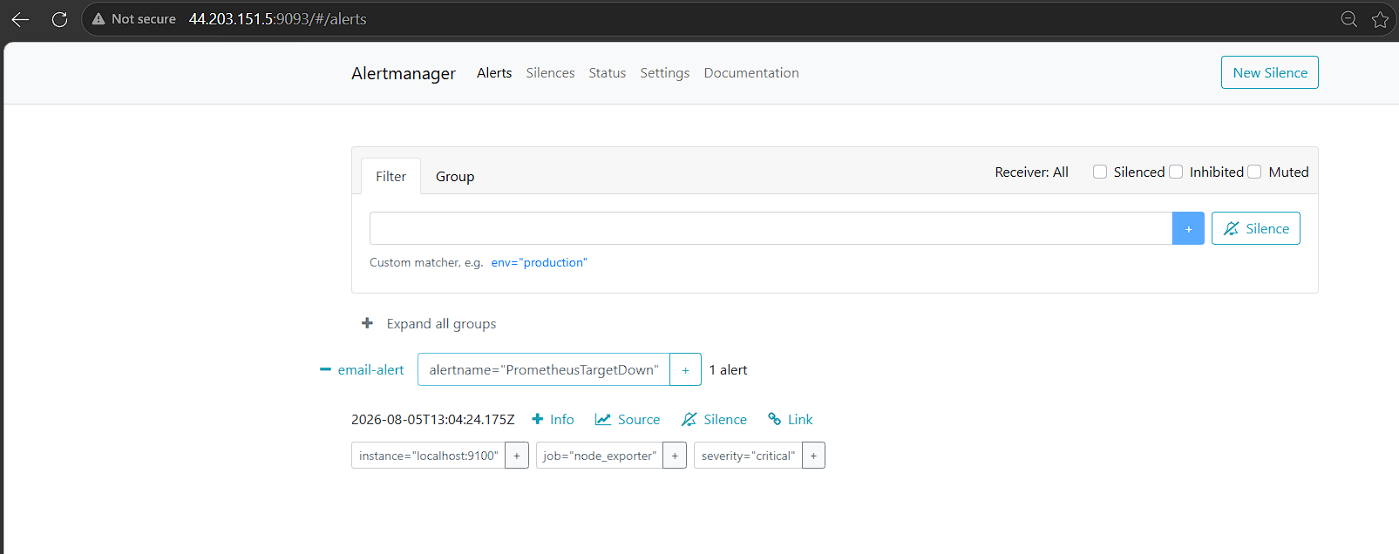
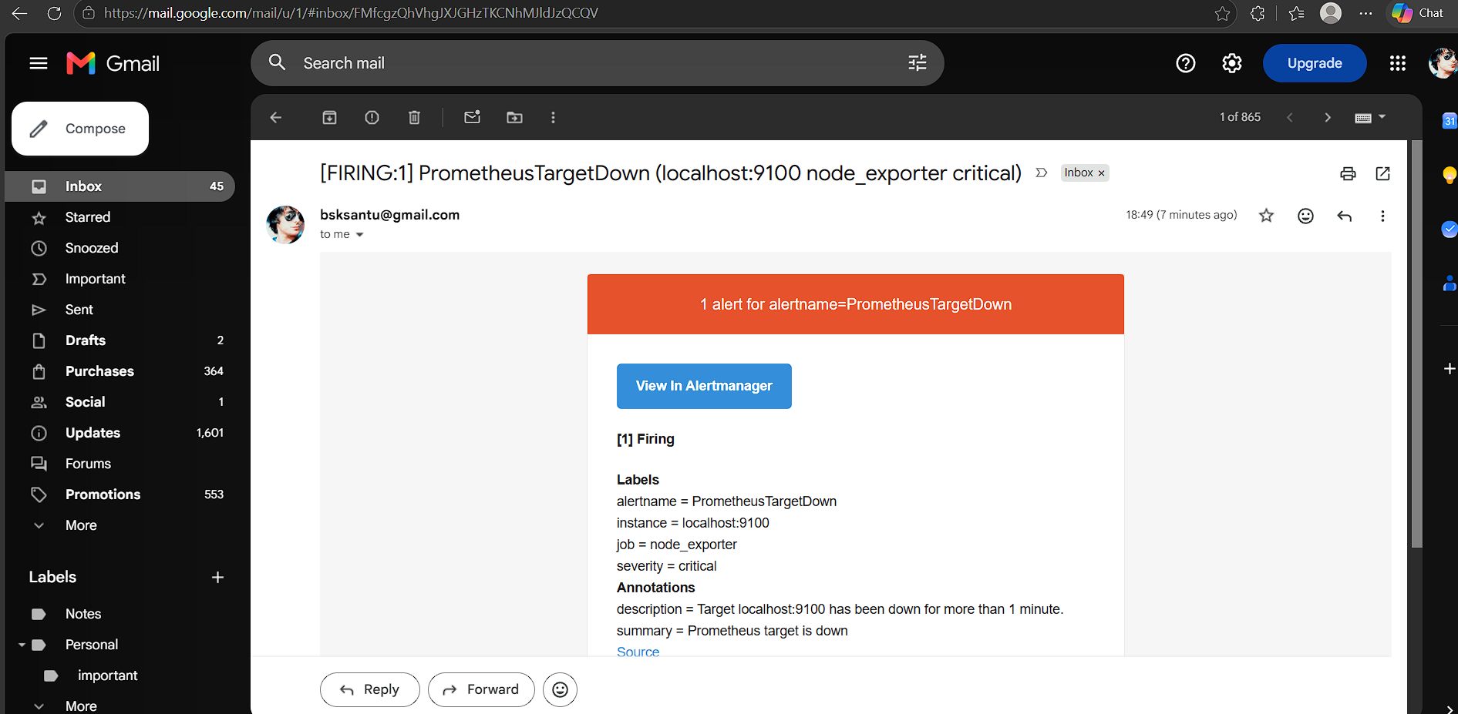
Actual Outcome
Alertmanager was installed and configured as a systemd service. Prometheus was integrated with Alertmanager, and email notifications were configured for triggered alerts.

6. Install Grafana and add Prometheus as a data source.

Objective
Install Grafana and configure Prometheus as the data source for monitoring and visualization.
Prerequisites
Prometheus should be installed and running.
Prometheus should be accessible on port 9090.
Amazon Linux 2023 server with sudo access
Steps
1. Add Grafana repository
sudo tee /etc/yum.repos.d/grafana.repo <<'EOF'
[grafana]
name=grafana
baseurl=https://rpm.grafana.com
repo_gpgcheck=1
enabled=1
gpgcheck=1
gpgkey=https://rpm.grafana.com/gpg.key
EOF

2. Install Grafana
sudo dnf install -y grafana

3. Start and enable Grafana
sudo systemctl daemon-reload
sudo systemctl start grafana-server
sudo systemctl enable grafana-server

Check:
sudo systemctl status grafana-server

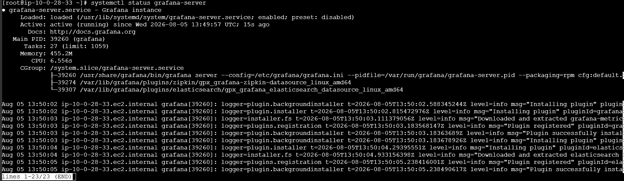
4. Access Grafana
Open in browser:
http://<Public-IP>:3000

Default login:
Username: admin
Password: admin

Grafana will ask you to change the password after the first login.

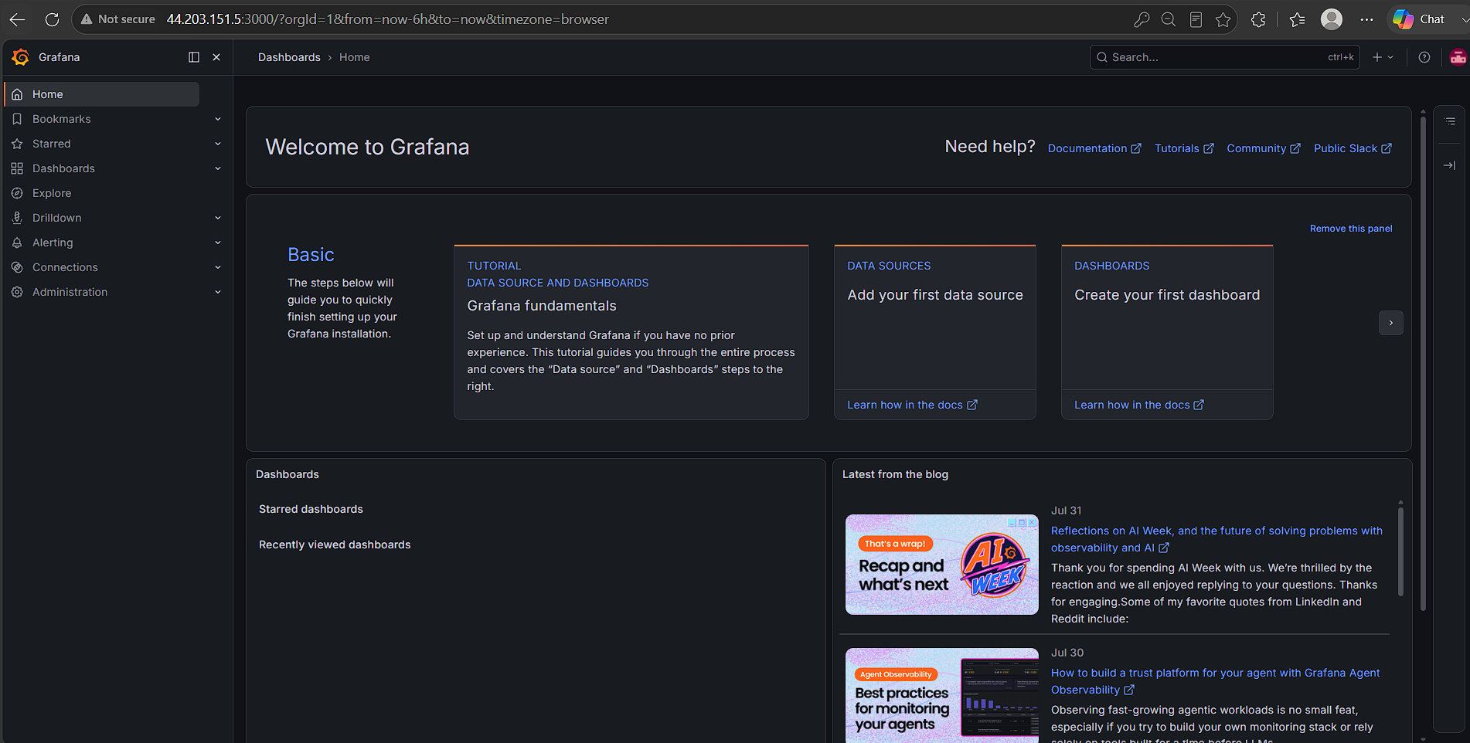
5. Add Prometheus Data Source
In Grafana:
Connections
↓
Data Sources
↓
Add data source
↓
Prometheus

For Prometheus server URL, enter:

http://localhost:9090

Click:

Save & test

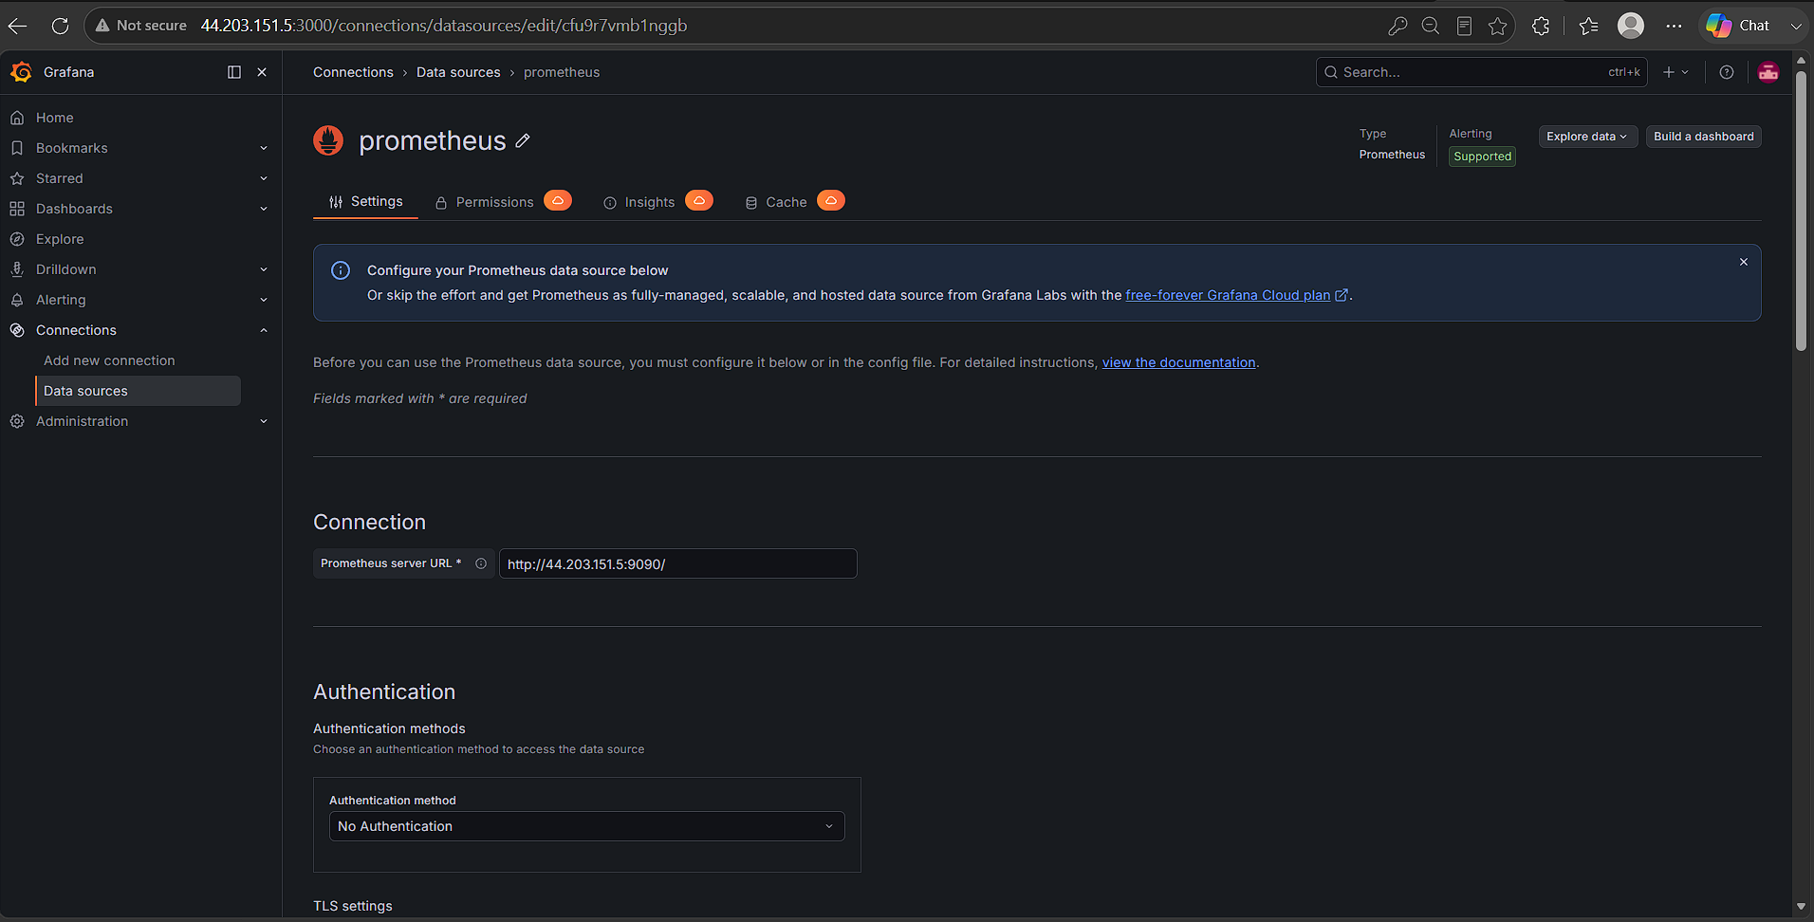
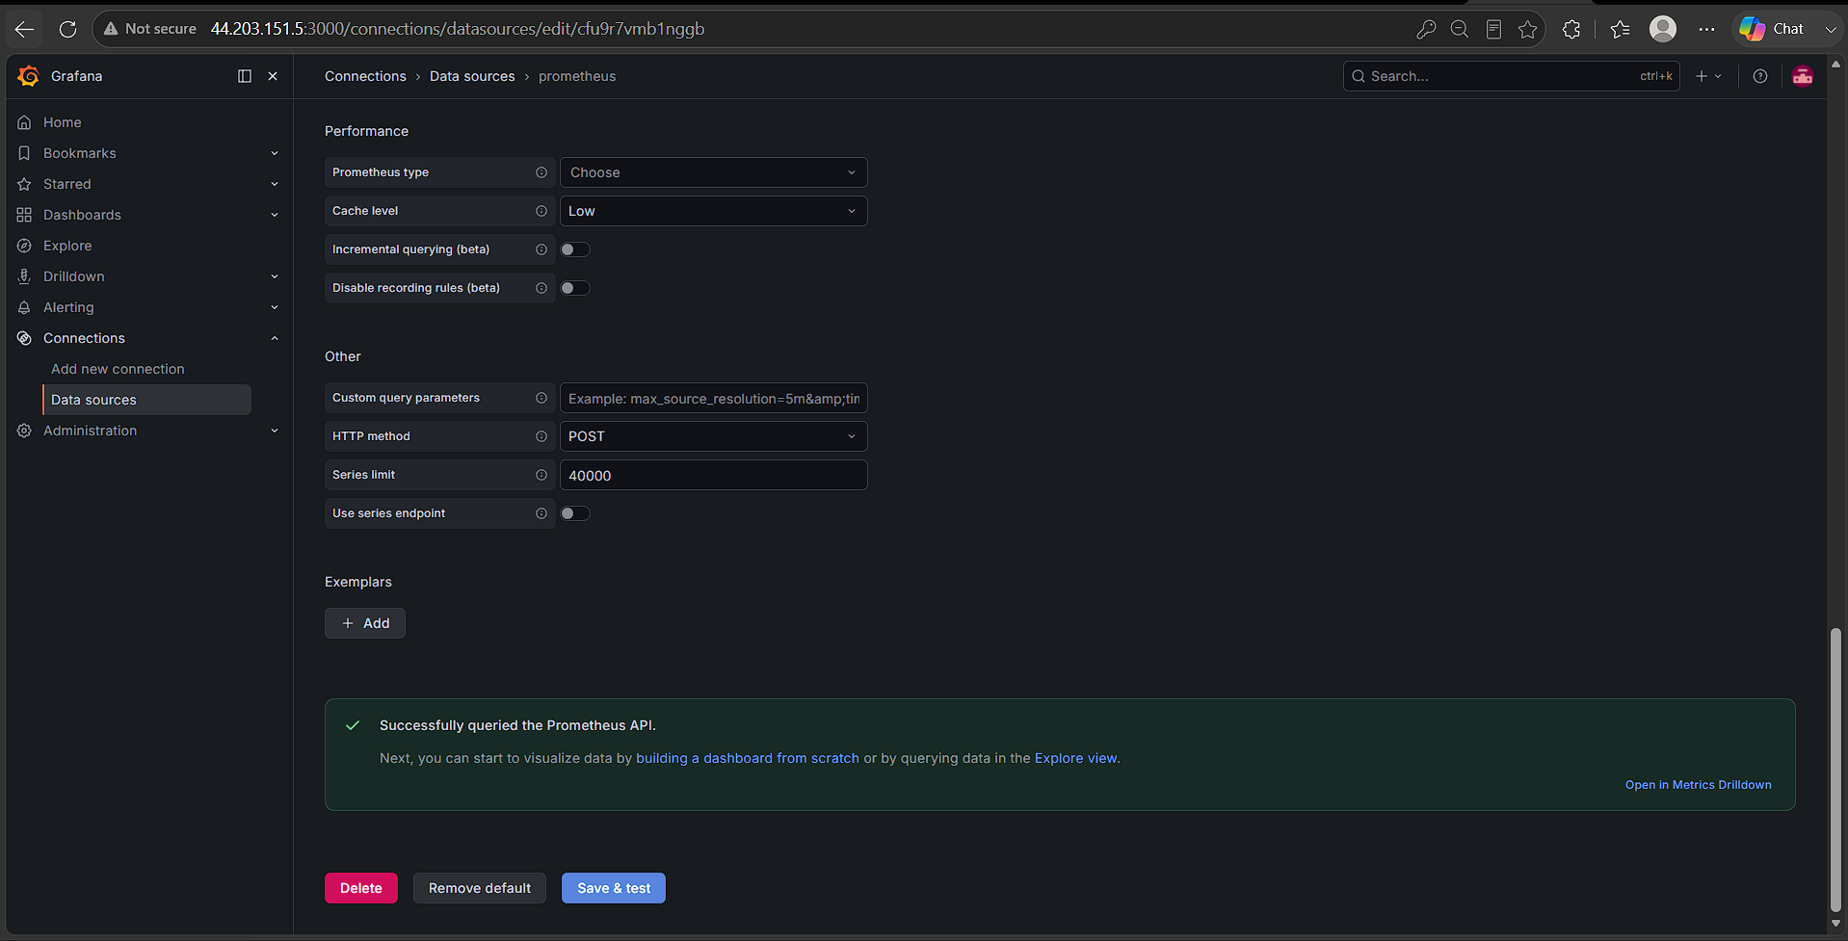
Expected Outcome
Grafana should successfully connect to Prometheus and be ready to create dashboards using Prometheus metrics.
Important AWS Security Group

Allow:

TCP 3000 → Your IP

You do not need to expose port 9090 publicly if Grafana and Prometheus are running on the same server, because Grafana can access Prometheus using:

http://localhost:9090

Troubleshooting
If Grafana doesn't open:
sudo systemctl status grafana-server
sudo ss -lntp | grep 3000

If Prometheus connection fails:
curl http://localhost:9090/-/healthy

7. Configure Prometheus for service discovery of dynamic targets.

Objective
Configure Prometheus to automatically discover dynamic targets instead of manually adding IP addresses.
Prerequisites
Prometheus installed and running.
Dynamic targets should be available through a service-discovery mechanism.

Steps

1. Edit Prometheus configuration

sudo vi /opt/prometheus-3.13.2.linux-amd64/prometheus.yml
using EC2 service discovery:

scrape_configs:
- job_name: "ec2-nodes"
ec2_sd_configs:
- region: us-east-1
port: 9100

relabel_configs:
- source_labels: [__meta_ec2_tag_Name]
target_label: instance_name

Attach an IAM Role to the Prometheus EC2 instance
Go to AWS Console → IAM → Policies → Create policy.
{
"Version": "2012-10-17",
"Statement": [
{
"Effect": "Allow",
"Action": [
"ec2:DescribeInstances",
"ec2:DescribeTags"
],
"Resource": "*"
}
]
}

PrometheusEC2DiscoveryPolicy

Create an IAM Role

IAM → Roles → Create role
Trusted entity type:
AWS service

Use case:
EC2

Attach: PrometheusEC2DiscoveryPolicy

Attach the role to your Prometheus EC2 instance

In AWS Console:
EC2 → Instances → select Prometheus instance
Then:
Actions
→ Security
→ Modify IAM role

Select: PrometheusEC2DiscoveryRole

Update IAM role

Verify the IAM role from the server

curl http://169.254.169.254/latest/meta-data/iam/info

If IMDSv2 is required, use:

TOKEN=$(curl -X PUT \
-H "X-aws-ec2-metadata-token-ttl-seconds: 21600" \
http://169.254.169.254/latest/api/token)

curl -H "X-aws-ec2-metadata-token: $TOKEN" \
http://169.254.169.254/latest/meta-data/iam/info

You should see information about the IAM role.

You can also check the role name:

TOKEN=$(curl -s -X PUT \
-H "X-aws-ec2-metadata-token-ttl-seconds: 21600" \
http://169.254.169.254/latest/api/token)

curl -s -H "X-aws-ec2-metadata-token: $TOKEN" \
http://169.254.169.254/latest/meta-data/iam/security-credentials/

Verify AWS API access

aws sts get-caller-identity

aws ec2 describe-instances --region us-east-1

2. Validate the configuration

cd /opt/prometheus-3.13.2.linux-amd64
./promtool check config prometheus.yml

3. Restart Prometheus

sudo systemctl restart prometheus
sudo systemctl status prometheus

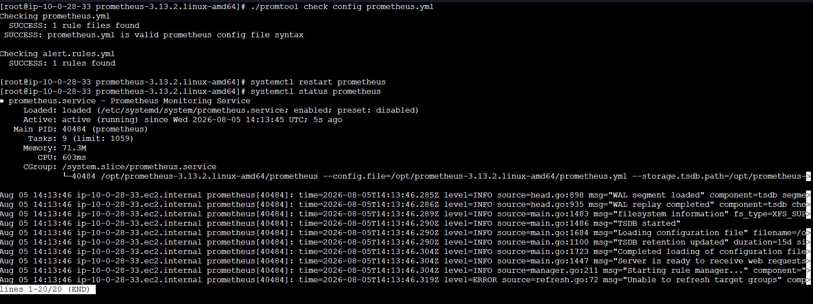
4. Verify discovered targets

Open:
http://<Public-IP>:9090/targets

Prometheus should automatically discover the EC2 instances and scrape their Node Exporter metrics.
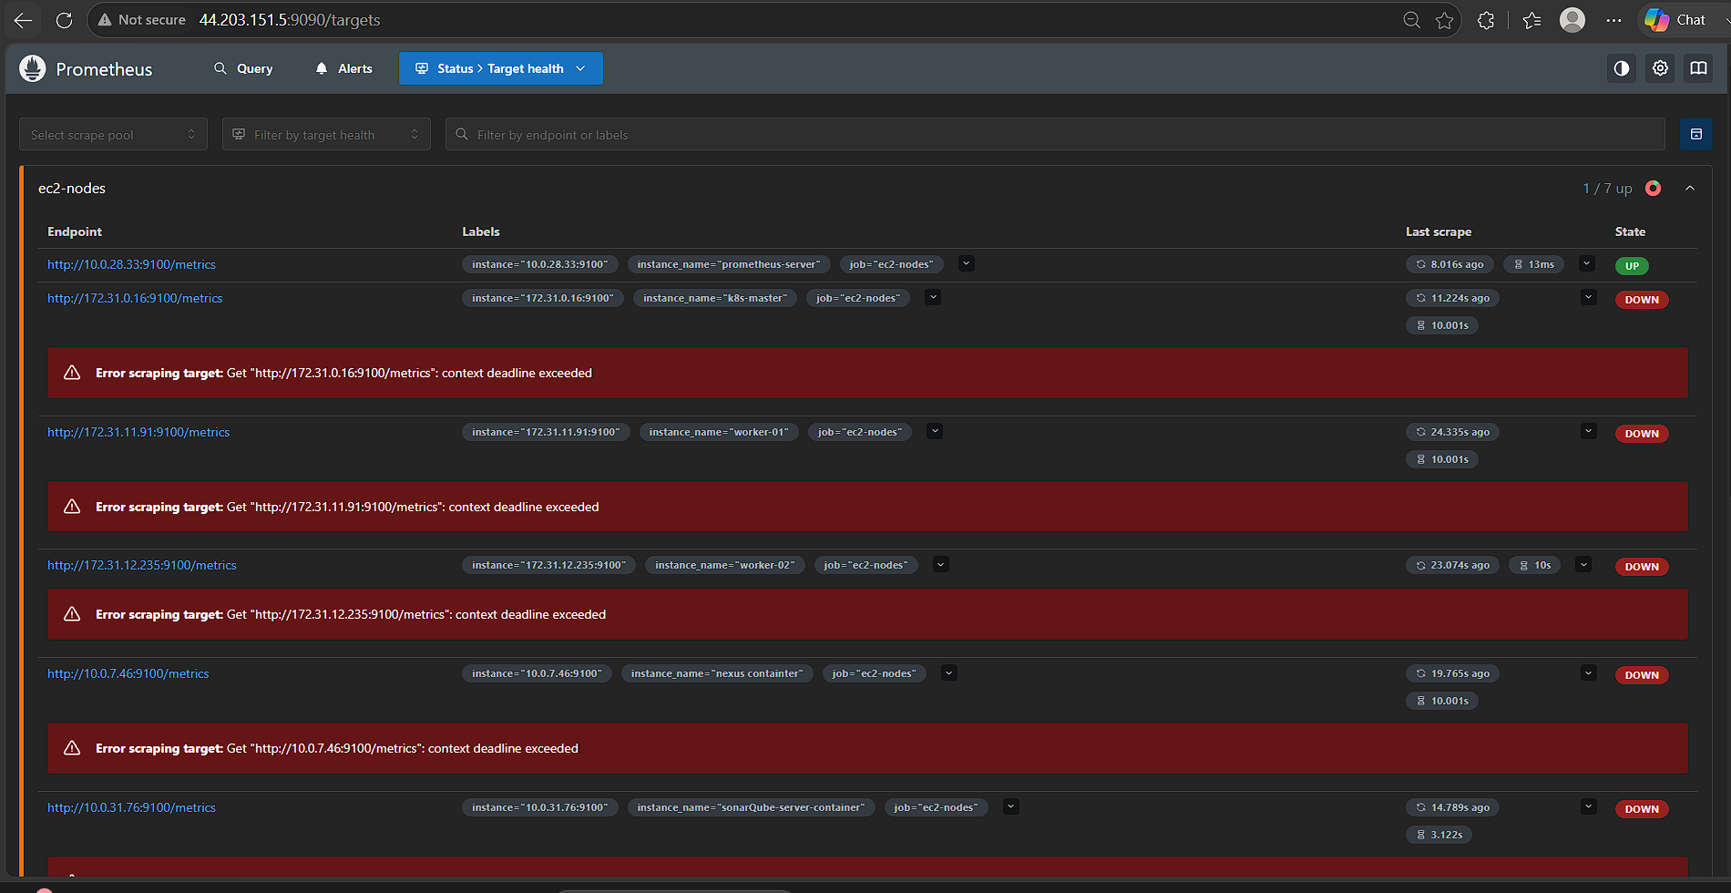
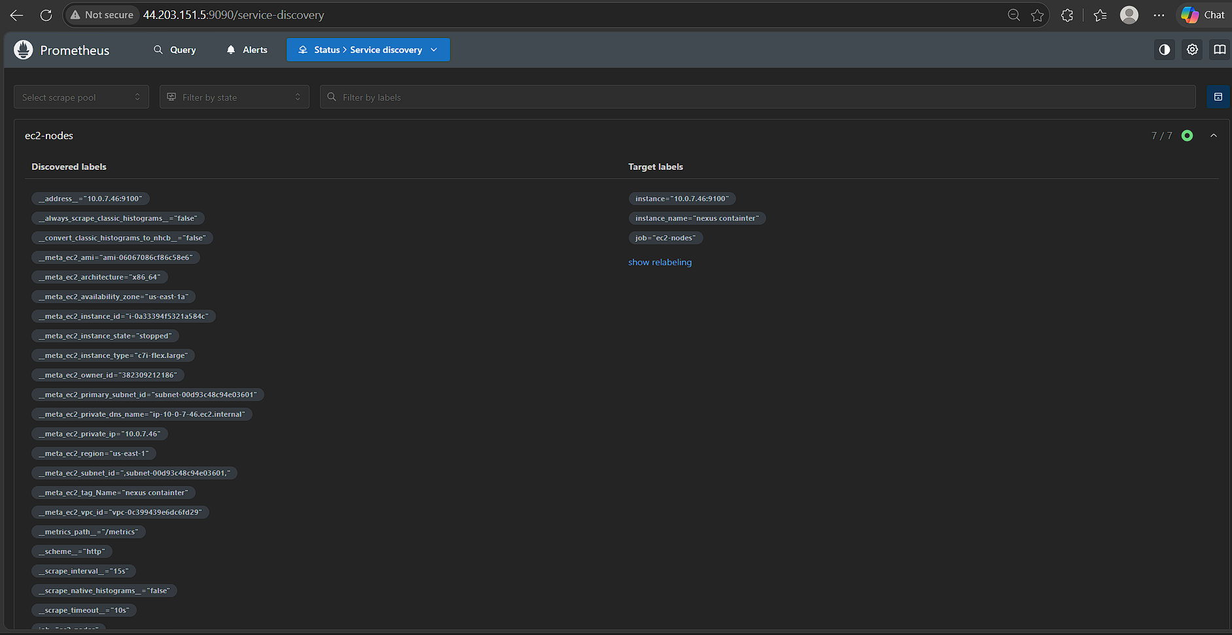
Expected Outcome

Prometheus automatically discovers new or removed EC2 targets, eliminating the need to manually update prometheus.yml whenever targets change.

8. Create alerting rules for monitoring disk space.

Objective

To create Prometheus alerting rules for monitoring disk-space utilization on EC2 instances using Node Exporter metrics.
The alerts will notify when available disk space falls below defined thresholds:
Warning: Less than 20% free disk space
Critical: Less than 10% free disk space

Prerequisites

Before configuring the alerting rules, ensure the following are available:
Prometheus is installed and running.
Node Exporter is installed and running on the monitored EC2 instances.
Prometheus is successfully scraping Node Exporter.
Prometheus EC2 service discovery is configured.
Prometheus configuration contains the rule_files section.
promtool is available for validating Prometheus configuration and rules.
Verify Prometheus:
sudo systemctl status prometheus

Verify Node Exporter:

sudo systemctl status node_exporter
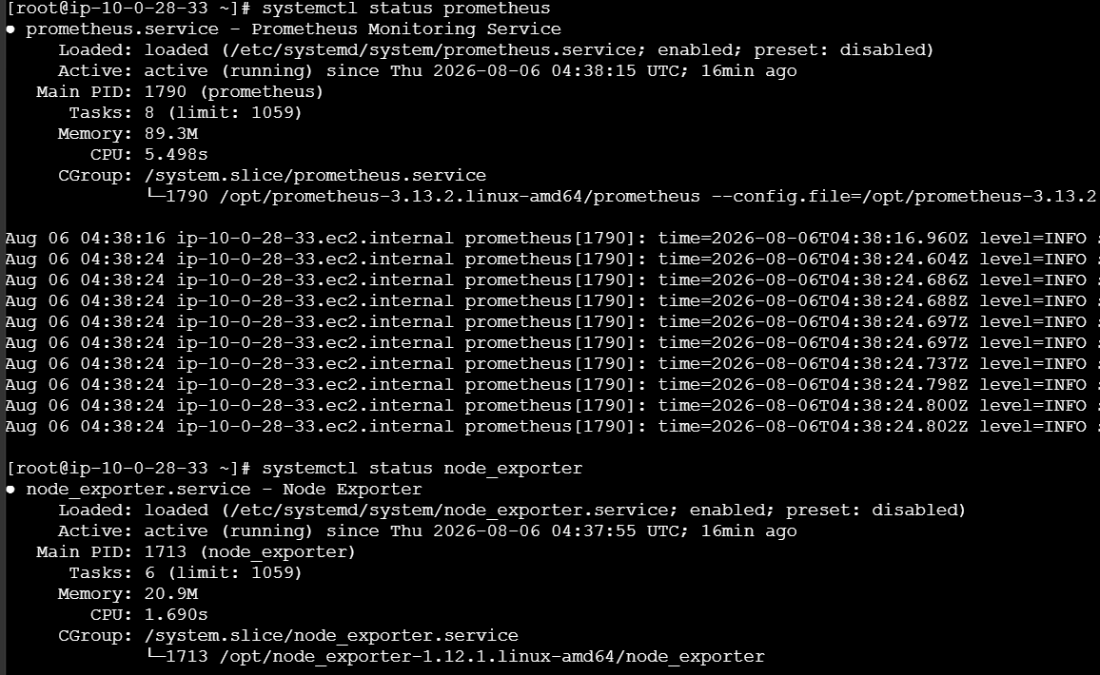

Verify the Prometheus target:

curl -s http://localhost:9090/api/v1/targets | python3 -m json.tool

The Node Exporter target should show:

"health": "up"
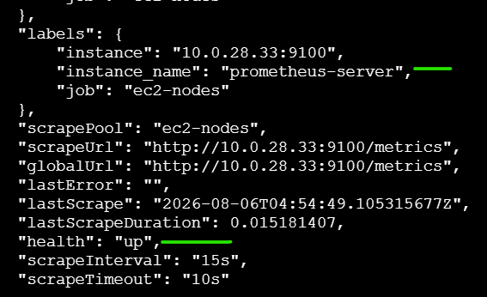

Architecture

EC2 Instance
|
|
Node Exporter :9100
|
|
v
Prometheus
|
|
node_filesystem_* metrics
|
v
Alerting Rules
alert.rules.yml
|
+-------+-------+
| |
< 20% < 10%
| |
Warning Critical

Prometheus Configuration

Prometheus needs to know where the alerting rules are located.

vi /opt/prometheus-3.13.2.linux-amd64/prometheus.yml

Make sure the following exists:

rule_files:
- "alert.rules.yml"

Your configuration already contains:
rule_files:
- "alert.rules.yml"

Therefore, no additional rule_files configuration is required.

Create Alert Rules File

Navigate to the Prometheus directory:
cd /opt/prometheus-3.13.2.linux-amd64

Create the alerting rules file:

vi alert.rules.yml

Add the following:

groups:
- name: disk-space-alerts

rules:

- alert: DiskSpaceWarning
expr: |
(
node_filesystem_avail_bytes{
fstype!~"tmpfs|devtmpfs|overlay|squashfs|proc|sysfs|cgroup.*",
mountpoint!~"/(proc|sys|dev|run|boot)"
}
/
node_filesystem_size_bytes{
fstype!~"tmpfs|devtmpfs|overlay|squashfs|proc|sysfs|cgroup.*",
mountpoint!~"/(proc|sys|dev|run|boot)"
}
) * 100 < 20
for: 5m
labels:
severity: warning
annotations:
summary: "Low disk space"
description: "{{ $labels.instance }} has less than 20% disk space remaining on {{ $labels.mountpoint }}."

- alert: DiskSpaceCritical
expr: |
(
node_filesystem_avail_bytes{
fstype!~"tmpfs|devtmpfs|overlay|squashfs|proc|sysfs|cgroup.*",
mountpoint!~"/(proc|sys|dev|run|boot)"
}
/
node_filesystem_size_bytes{
fstype!~"tmpfs|devtmpfs|overlay|squashfs|proc|sysfs|cgroup.*",
mountpoint!~"/(proc|sys|dev|run|boot)"
}
) * 100 < 10
for: 5m
labels:
severity: critical
annotations:
summary: "Critical disk space"
description: "{{ $labels.instance }} has less than 10% disk space remaining on {{ $labels.mountpoint }}."
Explanation of the Alert Rules

DiskSpaceWarning

alert: DiskSpaceWarning

This alert monitors disk utilization and fires when available disk space is below 20%.
The expression:

(
node_filesystem_avail_bytes
/
node_filesystem_size_bytes
) * 100 < 20

calculates the percentage of available disk space.

Example
If:
Total disk = 100 GB
Available = 15 GB
Then:
15 / 100 × 100 = 15%
Since:
15% < 20%
the DiskSpaceWarning alert will fire.
DiskSpaceCritical
alert: DiskSpaceCritical
This alert fires when available disk space falls below 10%.
For example:
Total disk = 100 GB
Available = 8 GB
Calculation:
8 / 100 × 100 = 8%
Since:
8% < 10%
the critical alert will fire.

7. Why for: 5m Is Used
The rules contain:
for: 5m
This means the condition must remain true continuously for 5 minutes before the alert changes to the firing state.
This prevents temporary fluctuations from generating unnecessary alerts.
For example:
Disk < 20%
|
+---- 1 minute → No alert
|
+---- 3 minutes → No alert
|
+---- 5 minutes → Alert FIRING

8. Severity Labels
The warning alert contains:
labels:
severity: warning
The critical alert contains:
labels:
severity: critical
This allows alerts to be categorized based on severity.
Alert | Condition | Severity
DiskSpaceWarning | Free space < 20% | Warning
DiskSpaceCritical | Free space < 10% | Critical

9. Alert Annotations
The configuration contains:
annotations:
summary: "Low disk space"
description: "{{ $labels.instance }} has less than 20% disk space remaining on {{ $labels.mountpoint }}."
Annotations provide additional information about the alert.
For example, Prometheus could display:
Summary:
Low disk space
Description:
10.0.28.33:9100 has less than 20% disk space remaining on /

10. Validate Alerting Rules
Before restarting Prometheus, validate the rules.
Run:
cd /opt/prometheus-3.13.2.linux-amd64
Then:
./promtool check rules alert.rules.yml
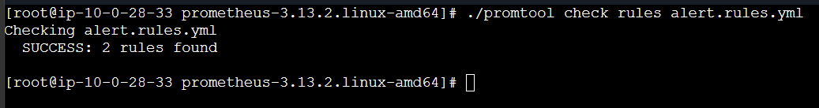
Expected output:
Checking alert.rules.yml
SUCCESS: 2 rules found
This confirms that the alert rules are syntactically correct.

11. Validate Prometheus Configuration
Run:
./promtool check config prometheus.yml
Expected:
Checking prometheus.yml
SUCCESS: prometheus.yml is valid prometheus config file syntax
If you receive an error, do not restart Prometheus until the configuration is corrected.
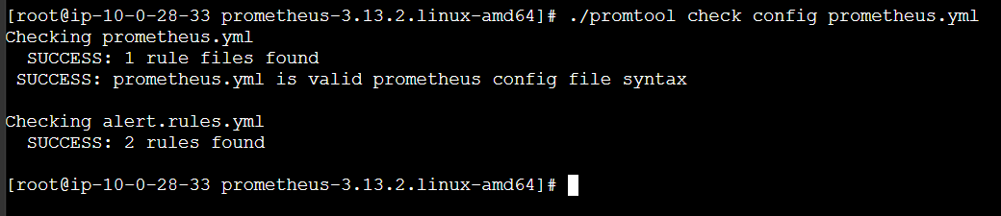
12. Restart Prometheus
After successful validation:
sudo systemctl restart prometheus
Check the service:
sudo systemctl status prometheus
Expected:
Active: active (running)
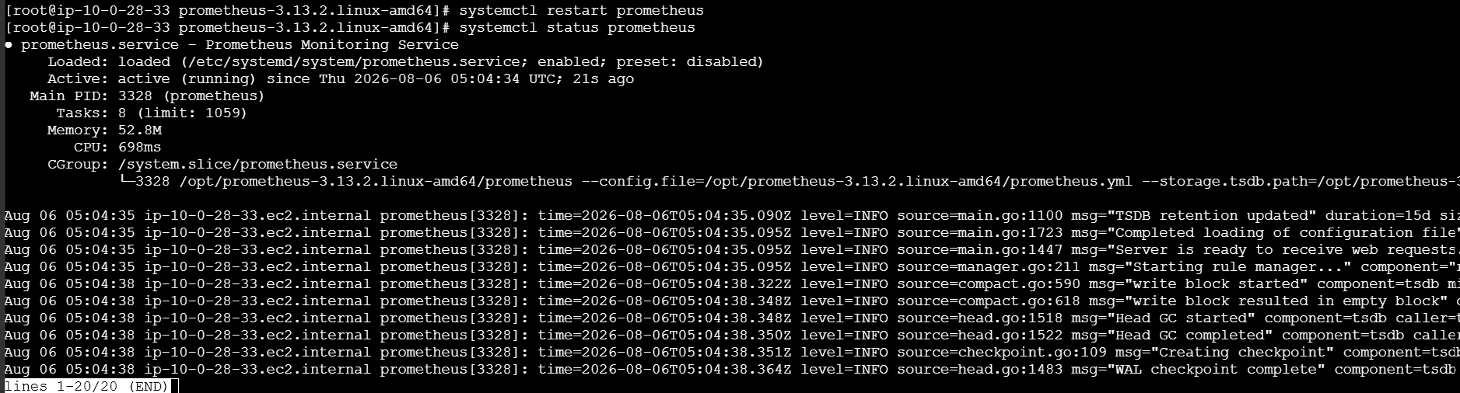
13. Check Prometheus Logs
Check whether Prometheus loaded the rules successfully:
sudo journalctl -u prometheus --since "2 minutes ago" --no-pager
You should not see errors related to:
alert.rules.yml

14. Verify Alert Rules in Prometheus
Open the Prometheus web interface:
http://<PROMETHEUS-IP>:9090
Navigate to:
Alerts
You should see:
DiskSpaceWarning
DiskSpaceCritical
Initially, they will normally be:
INACTIVE
when the disk has sufficient free space.
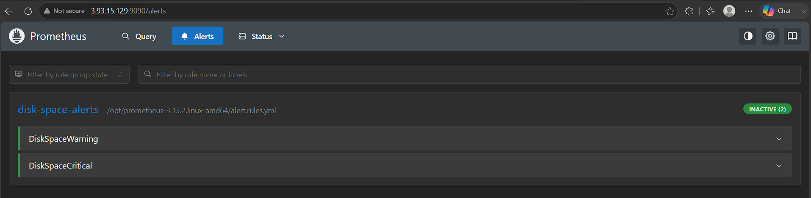
15. Verify Using Prometheus API
You can also verify the rules from the command line:
curl -s http://localhost:9090/api/v1/rules | python3 -m json.tool
You should find:
DiskSpaceWarning
DiskSpaceCritical
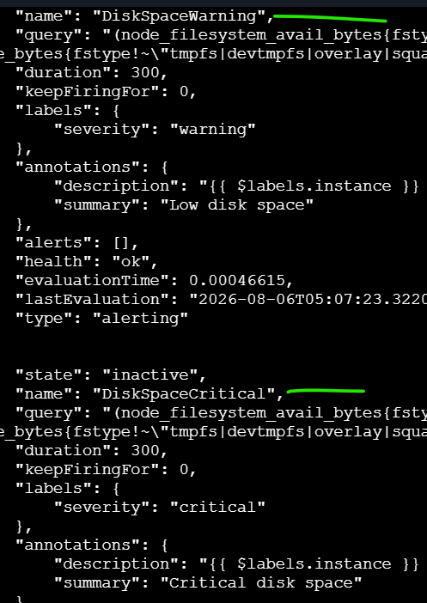
16. Verify Disk Metrics
Prometheus receives disk metrics from Node Exporter.
Check:
node_filesystem_avail_bytes
and:
node_filesystem_size_bytes
You can test the disk percentage calculation directly in Prometheus:
(
node_filesystem_avail_bytes
/
node_filesystem_size_bytes
) * 100
This displays the percentage of free disk space.
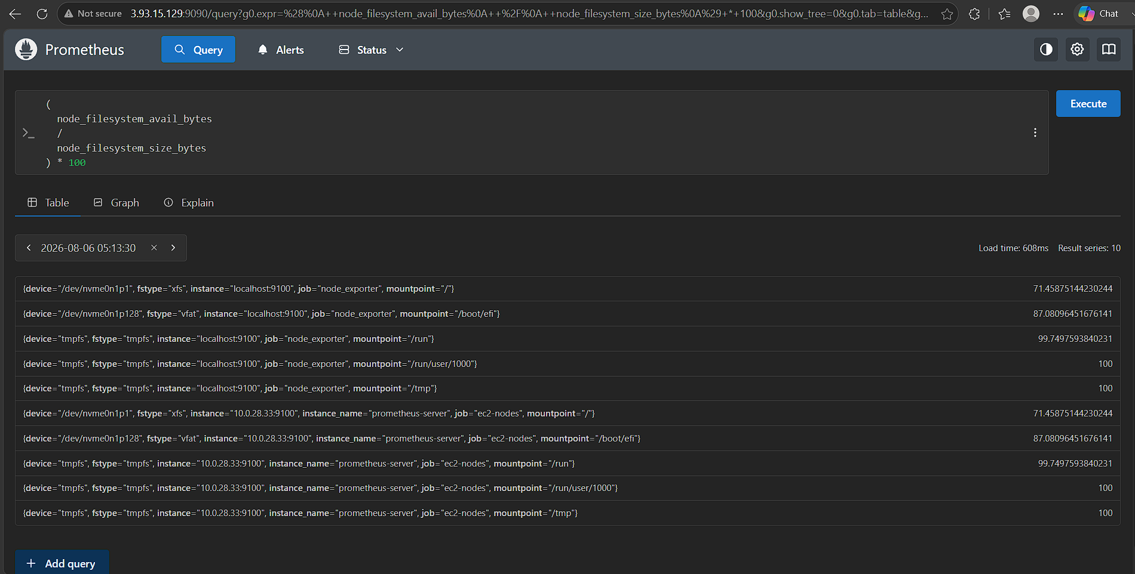
17. Testing the Alert
For lab/testing purposes, you can temporarily change:
< 20
to:
< 90
This makes the alert easier to trigger because most disks will have less than 90% free space.
After changing the rule:
./promtool check rules alert.rules.yml
Then:
sudo systemctl restart prometheus
Wait for the configured:
for: 5m
period.
Then open:
http://<PROMETHEUS-IP>:9090/alerts
You should see:
DiskSpaceWarning
State: FIRING
Severity: warning
After testing, change the threshold back to < 20.
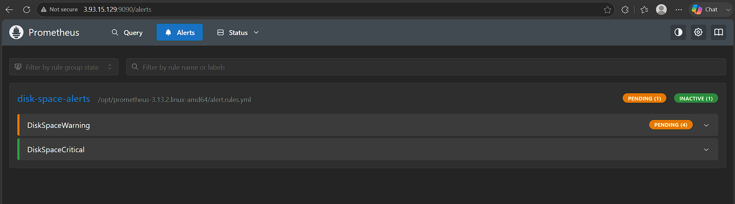
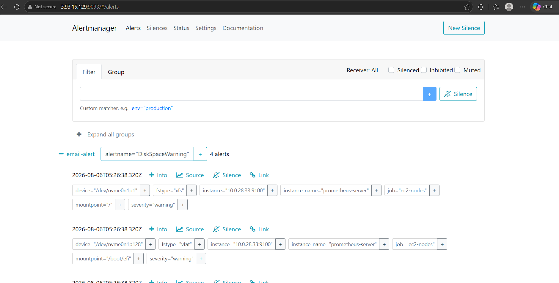
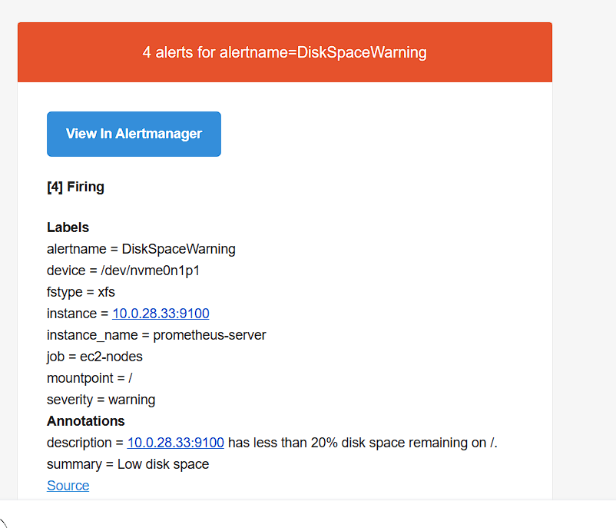
18. Expected Outcome
After successful configuration:
Normal condition
Disk free space > 20%
|
v
No alert
Warning condition
Disk free space < 20%
|
| continuously for 5 minutes
v
DiskSpaceWarning
severity = warning
Critical condition
Disk free space < 10%
|
| continuously for 5 minutes
v
DiskSpaceCritical
severity = critical

Verification Checklist
Check | Command | Expected Result
Prometheus running | systemctl status prometheus | Active
Node Exporter running | systemctl status node_exporter | Active
Target status | /api/v1/targets | health: up
Rules validation | promtool check rules | SUCCESS
Config validation | promtool check config | SUCCESS
Warning alert | Prometheus → Alerts | Available
Critical alert | Prometheus → Alerts | Available
Disk metrics | node_filesystem_avail_bytes | Metrics available

Final Result

The disk monitoring configuration provides two levels of alerting:
Disk Space
|
+----------+----------+
| |
< 20% < 10%
| |
v v
DiskSpaceWarning DiskSpaceCritical
WARNING CRITICAL
for 5m for 5m

Actual Outcome: Prometheus monitors filesystem disk space through Node Exporter and generates DiskSpaceWarning when free disk space falls below 20% and DiskSpaceCritical when it falls below 10% for at least 5 minutes.

9. Create a custom Grafana dashboard using Prometheus metrics for specific insights.

Objective
To create a custom Grafana dashboard using Prometheus as the data source and visualize important infrastructure metrics such as:
CPU utilization
Memory utilization
Disk utilization
Disk available space
Network traffic
Node availability
Prometheus health
EC2 instance monitoring through node_exporter
The dashboard will provide a centralized view of the infrastructure monitored by Prometheus.
Architecture

EC2 Instances
|
Node Exporter
|
| Metrics :9100
v
Prometheus
|
| PromQL
v
Grafana
|
v
Custom Monitoring Dashboard

Prerequisites

Component | Purpose
Prometheus | Collects and stores metrics
Grafana | Visualizes Prometheus metrics
Node Exporter | Provides Linux system metrics
EC2 Service Discovery | Automatically discovers EC2 instances
PromQL | Queries Prometheus metrics

sudo systemctl status prometheus
sudo systemctl status node_exporter
sudo systemctl status grafana-server

Configure Prometheus as Grafana Data Source

http://<GRAFANA-IP>:3000

Connections
↓
Data sources
↓
Add new data source
↓
Prometheus

Set the Prometheus URL.
If Grafana and Prometheus are running on the same server:
http://localhost:9090
If Grafana is running on another server:
http://<PROMETHEUS-PRIVATE-IP>:9090
Click:
Save & test
You should see:
Successfully queried the Prometheus API.

Create a New Dashboard
Dashboards
↓
New
↓
New Dashboard
↓
Add visualization

Select your Prometheus data source.
Give the dashboard a meaningful name, for example:
EC2 Infrastructure Monitoring

Dashboard Panel 1 – CPU Utilization
Panel Name
CPU Utilization
PromQL
100 - (
avg by (instance) (
rate(node_cpu_seconds_total{mode="idle"}[5m])
) * 100
)
This calculates the percentage of CPU currently being used.
Visualization
Choose:
Time series
Recommended unit:
Percent (0-100)

7. Dashboard Panel 2 – Memory Utilization
Panel Name
Memory Utilization
PromQL
100 * (
1 -
node_memory_MemAvailable_bytes
/
node_memory_MemTotal_bytes
)
Visualization
Gauge
or
Time series
Unit
Percent (0-100)
This provides a quick view of how much memory is being consumed.

8. Dashboard Panel 3 – Disk Utilization
This is particularly relevant to the disk-space monitoring you just configured.
Panel Name
Disk Utilization
PromQL
100 * (
1 -
node_filesystem_avail_bytes{
fstype!~"tmpfs|vfat",
mountpoint="/"
}
/
node_filesystem_size_bytes{
fstype!~"tmpfs|vfat",
mountpoint="/"
}
)
Your Prometheus output already shows the / filesystem metric.
For example, your current result showed approximately:
71.45
which means approximately:
71.45% disk utilization
Visualization
Gauge
Unit
Percent (0-100)

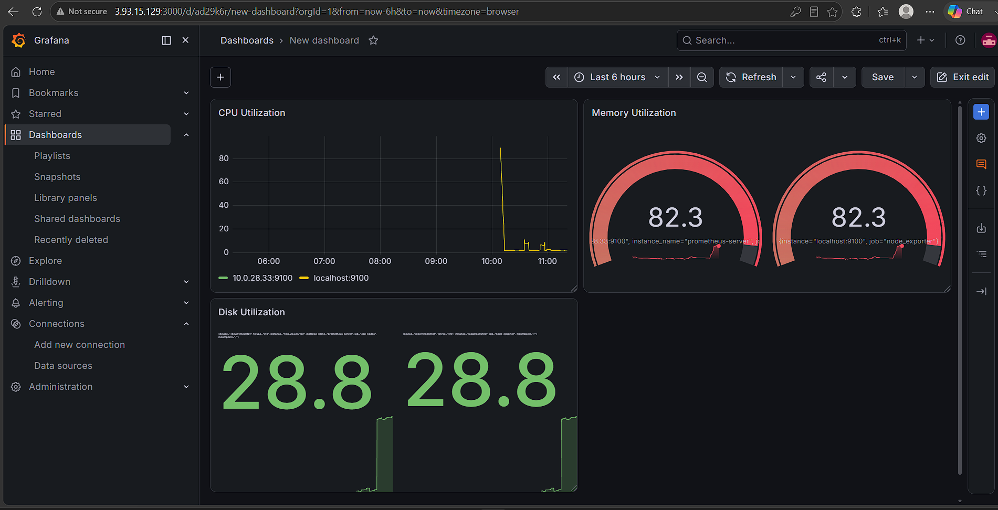
Expected Outcome
After completing the configuration, Grafana should provide a single dashboard showing:
EC2 Infrastructure Monitoring

CPU
├── Prometheus Server
├── EC2 Instance 2
└── EC2 Instance 3

Memory
├── Prometheus Server
└── Other EC2 Instances

Disk
├── Disk Utilization %
├── Available Disk
└── Inode Usage

Network
├── Receive Traffic
└── Transmit Traffic

Availability
├── Node Exporter UP/DOWN
└── Prometheus UP/DOWN

The dashboard will allow you to quickly identify:
Which EC2 instance has high CPU usage
Which instance is consuming excessive memory
Which server is running low on disk space
Which Node Exporter is down
Network traffic trends
Filesystem inode exhaustion
Prometheus availability

Difficulties / Troubleshooting
Problem 1: Dashboard shows "No data"
Check Prometheus targets:
http://<PROMETHEUS-IP>:9090/targets
or:
curl -s http://localhost:9090/api/v1/targets
You already used this successfully and confirmed that ec2-nodes is being discovered.

Problem 2: Node Exporter target is DOWN
On the affected EC2 instance:
sudo systemctl status node_exporter
Check port:
sudo ss -lntp | grep 9100
Test locally:
curl http://localhost:9100/metrics
From the Prometheus server:
curl http://<PRIVATE-IP>:9100/metrics
If this fails remotely, check the EC2 Security Group.
Allow:
TCP
Port: 9100
Source: Prometheus Security Group
Prefer allowing the Prometheus server's security group rather than opening port 9100 to 0.0.0.0/0.
Final Dashboard Summary
Panel | PromQL Metric | Visualization
CPU Utilization | node_cpu_seconds_total | Time series
Memory Utilization | node_memory_* | Gauge
Disk Utilization | node_filesystem_* | Gauge
Available Disk | node_filesystem_avail_bytes | Time series
Total Disk | node_filesystem_size_bytes | Stat
Network Receive | node_network_receive_bytes_total | Time series
Network Transmit | node_network_transmit_bytes_total | Time series
Node Exporter Status | up{job="ec2-nodes"} | Table/Stat
Prometheus Status | up{job="prometheus"} | Stat
Inode Usage | node_filesystem_files_* | Gauge

Actual Outcome
The custom Grafana dashboard provides centralized visualization of Prometheus metrics from your EC2 instances, including CPU, memory, disk, network, filesystem, and exporter availability. The instance_name label from your EC2 service discovery configuration can also be used to identify individual EC2 machines in Grafana.

